Automated CI/CD Pipeline for Cloud Deployment

Introduction
Modern software tools allow teams to save time and avoid errors using automated pipelines.
In this lesson, you will create a complete, automated CI/CD pipeline for a Spring Boot application using GitHub Actions and a cloud deployment target. The pipeline will begin the moment you commit and push code to GitHub, and will end with a live, updated containerized application running in the cloud.
This lab builds on everything you’ve learned so far in CST-323—Java, Spring Boot, Maven, Docker, GitHub, and cloud services—but adds the missing link: automation. Instead of running container builds and deployments manually, you will configure GitHub to handle the entire process.
By the end of this lesson, you will have experienced the a workflow used by cloud engineers, DevOps specialists, and modern software development teams.

Learning Objectives
After completing this lesson, you will be able to:
1. Explain the purpose of a CI/CD pipeline
- Describe how Continuous Integration and Continuous Deployment improve software reliability and speed.
2. Configure GitHub Actions as a build-and-deployment pipeline
- Create a workflow file that automatically runs tests, compiles your Spring Boot app, builds a Docker image, and deploys it.
3. Package and version an application using Docker in an automated workflow
- Understand how pipelines produce new container versions based on Git commits.
4. Push container images to a cloud-based container registry
- Push images automatically to the GitHub Container Registry.
5. Deploy a container image to a cloud service without manual commands
- Update a running cloud application via automation rather than through manual CLI or portal steps.
6. Validate pipeline execution and troubleshoot failed builds
- Interpret build logs and common pipeline failure scenarios (tests breaking, registry permissions, deployment errors).

Tools Used in This Lesson
Since this module blends multiple systems together, here are all tools involved.
You have used these earlier in your GCU experience:
- Java Spring Boot – application framework.
- Maven – build, test, and dependency management tool.
- GitHub – version control and repository hosting.
- VS Code – your development environment.
- Docker – containerization of applications.
- AWS and Azure portals – manual deployment targets.
You should already be comfortable running containers locally and deploying them manually to cloud platforms.

New Tools / Concepts Introduced
These are new for this lesson and will be explained step-by-step in the tutorial:
1. GitHub Actions (NEW Core Feature)
GitHub Actions is a cloud-based automation platform built into GitHub.
You will use it to:
- Trigger workflows when code is pushed.
- Run Maven builds and tests automatically.
- Build Docker images automatically.
- Push to a container registry.
- Deploy to a cloud service.
Think of GitHub Actions as your "build server" or "robot developer."
2. CI vs CD (NEW Concepts)
- Continuous Integration (CI)
Code is integrated frequently; automated tests validate changes.
- Continuous Deployment (CD)
After CI succeeds, automated processes deploy the new version to production.
3. Container Registries (Expanded Use)
You've built containers locally, but now you'll connect to:
- GitHub Container Registry (GHCR)
Purpose: store versioned container images created by the pipeline.
Alternatives to GitHub
- Azure Container Registry (ACR) or
- AWS Elastic Container Registry (ECR) or
4. Automated Cloud Deployment (NEW Workflow)
Instead of logging into a cloud service manually and navigating a complex UI.
- GitHub will authenticate with the cloud.
- Pull the new container image.
- Update the running service with zero manual steps.
5. Secure Credential Management (NEW Concept)
Students will store deployment credentials in:
- GitHub Secrets
This protects cloud credentials and enables GitHub to deploy securely.

Steps for Automated CI/CD Pipeline for Cloud Deployment

Step 1 — Overview and Setup
- Review the Architecture of the Pipeline
The following flow chart shows the entire process used in this tutorial.
Triggers workflow
Developer
GitHub Repo
GitHub Action CI
(test & build)
Checkout code
mvn test / package
Build Docker Image
Container Registry
Github Action CD
(Deploy job)
Login to cloud
Update service to new image tag
Live Application URL
Cloud Deployment Target
Git push
Push image
New image available
Pull & run container
2. Confirm Prerequisites
- Verify that both Maven and Docker are installed locally.
- Verify GitHub account is created and working.
- Confirm previous CST-323 labs were completed (local Docker build, manual cloud deployments).

Step 2 — Prepare the Application
Download and Explore the Starter Spring Boot App. The instructor provides a minimal working Spring Boot app. Either download the starting application or copy and paste from this document.
https://github.com/shadsluiter/commentsappCICD

===== ./src/main/java/edu/shadsluiter/comments/CommentsApplication.java =====
package edu.shadsluiter.comments;

import org.springframework.boot.SpringApplication;
import org.springframework.boot.autoconfigure.SpringBootApplication;

@SpringBootApplication
public class CommentsApplication {

public static void main(String[] args) {
SpringApplication.run(CommentsApplication.class, args);
}

}

===== ./src/main/java/edu/shadsluiter/comments/controllers/MainController.java =====
package edu.shadsluiter.comments.controllers;

import org.springframework.stereotype.Controller;
import org.springframework.ui.Model;
import org.springframework.web.bind.annotation.GetMapping;
import org.springframework.web.bind.annotation.PostMapping;

import edu.shadsluiter.comments.data.CommentsDAO;

@Controller
public class MainController {

// Simple in-memory DAO instance for now
private final CommentsDAO commentsDAO = new CommentsDAO();

// Show the page with the list of comments
@GetMapping("/")
public String index(Model model) {
model.addAttribute("comments", commentsDAO.getComments());
return "index"; // resolves to src/main/resources/templates/index.html
}

// Handle the form submission
@PostMapping("/submitComment")
public String submitComment(String author, String content) {
commentsDAO.addComment(author, content);

// PRG pattern: redirect so refresh doesn’t resubmit the form
return "redirect:/";
}
}

===== ./src/main/java/edu/shadsluiter/comments/data/CommentsDAO.java =====
package edu.shadsluiter.comments.data;

import java.util.ArrayList;
import java.util.List;

import edu.shadsluiter.comments.model.AppComment;

public class CommentsDAO {

private List<AppComment> comments = new ArrayList<>();
private int nextId = 0;

public CommentsDAO() {
initialData();
}

private void initialData() {

if (comments.size() > 0) {
return;
}

AppComment comment1 = new AppComment(1, "Alice", "This is a great day to talk about life.");
AppComment comment2 = new AppComment(2, "Bob", "I agree with Alice!");
AppComment comment3 = new AppComment(3, "Charlie", "I feel like coding today.");
comments.add(comment1);
comments.add(comment2);
comments.add(comment3);
this.nextId = 4;
}

public void addComment(AppComment comment) {
comment.setId(nextId++);
comments.add(comment);
}

public void addComment(String author, String content) {
AppComment newComment = new AppComment(nextId++, author, content);
comments.add(newComment);
}

public List<AppComment> getComments() {
return comments;
}

public void clearComments() {
comments.clear();
nextId = 1;
}

public AppComment getCommentById(int id) {
for (AppComment comment : comments) {
if (comment.getId() == id) {
return comment;
}
}
return null;
}

public void updateComment(AppComment updatedComment) {
for (int i = 0; i < comments.size(); i++) {
if (comments.get(i).getId() == updatedComment.getId()) {
comments.set(i, updatedComment);
return;
}
}
}

public void deleteComment(int id) {
comments.removeIf(comment -> comment.getId() == id);
}

}

===== ./src/main/java/edu/shadsluiter/comments/model/AppComment.java =====
package edu.shadsluiter.comments.model;

public class AppComment {
private int id;
private String author;
private String content;

public AppComment(int id, String author, String content) {
this.id = id;
this.author = author;
this.content = content;
}

public int getId() {
return id;
}

public String getAuthor() {
return author;
}

public String getContent() {
return content;
}

public void setContent(String content) {
this.content = content;
}

public void setAuthor(String author) {
this.author = author;
}

public void setId(int id) {
this.id = id;
}

@Override

public String toString() {
return "Comment{" +
"id=" + id +
", author='" + author + '\'' +
", content='" + content + '\'' +
'}';
}

}

===== ./src/test/java/edu/shadsluiter/comments/CommentsApplicationTests.java =====
package edu.shadsluiter.comments;

import org.junit.jupiter.api.Test;
import org.springframework.boot.test.context.SpringBootTest;

@SpringBootTest
class CommentsApplicationTests {

@Test
void contextLoads() {
}

}
Thymeleaf templates MUST be in:
src/main/resources/templates/index.html
<!DOCTYPE html>
<html lang="en" xmlns:th="http://www.thymeleaf.org">
<head>
<meta charset="UTF-8">
<meta name="viewport" content="width=device-width, initial-scale=1.0">
<title>Comments Application</title>

<div class="container">
<h1>Welcome to the comments application!</h1>
<!-- table of comments-->
<table class="table">
<thead>
<tr>
<th scope="col">Id</th>
<th scope="col">Comment</th>
</tr>
</thead>
<tbody>
<tr th:each="comment : ${comments}">
<td th:text="${comment.content}">Sample comment content</td>
</tr>
</tbody>

</table>

<!-- form to add comments -->
<form th:action="@{/submitComment}" method="post">
<div class="mb-3">
<label for="content" class="form-label">New Comment</label>
<input type="text" class="form-control" id="content" name="content" required>
</div>
<div class="mb-3">
<label for="author" class="form-label">Your name</label>
<input type="text" class="form-control" id="author" name="author" required>
</div>
<button type="submit" class="btn btn-primary">Add Comment</button>
</form>

</body>
</html>

- Open the project in VS Code.
- Verify two steps:
  - mvn clean package runs successfully.
  - The app runs locally.

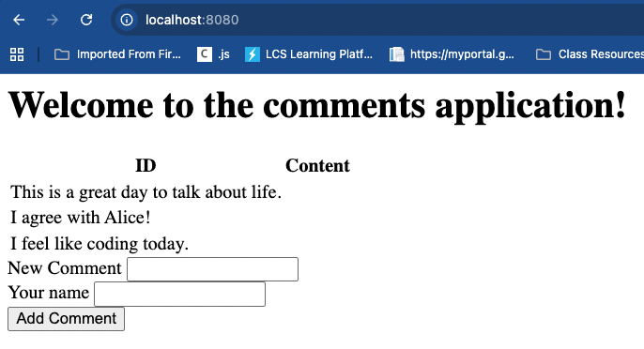
Figure 1 Application running on port 8080.

Add some new comments to the application to test the functionality.

Screen shot #1 – Local Application

- Take a screen shot of current status of the local application operating successfully.
- Paste the image into a Word document.
- Put a caption below the image explaining what is being demonstrated.

Preview of Upcoming Changes
This is only the starting state of the application. We will purposely modify the application incrementally, so that we can see the changes occur over several updates.
Version | Short Name | Goal | Description of Change | Typical Files Modified
v1 | Structured comments table | First obvious UI change, ties data fields to visible columns | Change the comments section from a raw list/paragraphs to a proper HTML table with columns: ID, Author, Comment. Ensure each row shows the comment’s id, author, and content. | templates/index.html (table markup)
v2 | Basic styling & layout (CSS update) | Make UI changes very visible; practice redeploying visual updates | Improve the look of the page: add custom fonts, colors, spacing, and a styled comment form (labels, inputs, button). Can use inline <style> or a simple CSS file in static. | templates/index.html, optional static/styles.css
v3 | Timestamps for each comment | Add a small data/model change plus a new UI field | Add a createdAt timestamp to each AppComment. Set it when sample comments are created and when new comments are submitted. Display a new “Submitted at” column in the table with a readable date/time. | model/AppComment.java (new field + getter), data/CommentsDAO.java (set timestamp), templates/index.html (new column)
v4 | Simple filter + summary (author filter) | Show a behavior change in the app with minimal logic | Add a text box or small form that lets the user filter comments by author (e.g., /?author=Alice). Show only matching comments and display a message like “Showing X of Y comments”. If no filter is applied, show all comments. | controllers/MainController.java (optional author param, filtering), templates/index.html (filter form + “X of Y” message)

Step 3. Create a New GitHub Repository
These steps will push the current app to a Github repo.

1 → Create repo on GitHub

2 → Initialize Git locally

3 → Link the remote

4 → Push your code
- Create the Repository on GitHub.com
  - Go to github.com
  - Click New Repository
  - Enter a name, e.g., comments-pipeline-demo
  - Do NOT check “Initialize with README”
(We want a clean empty repo.)
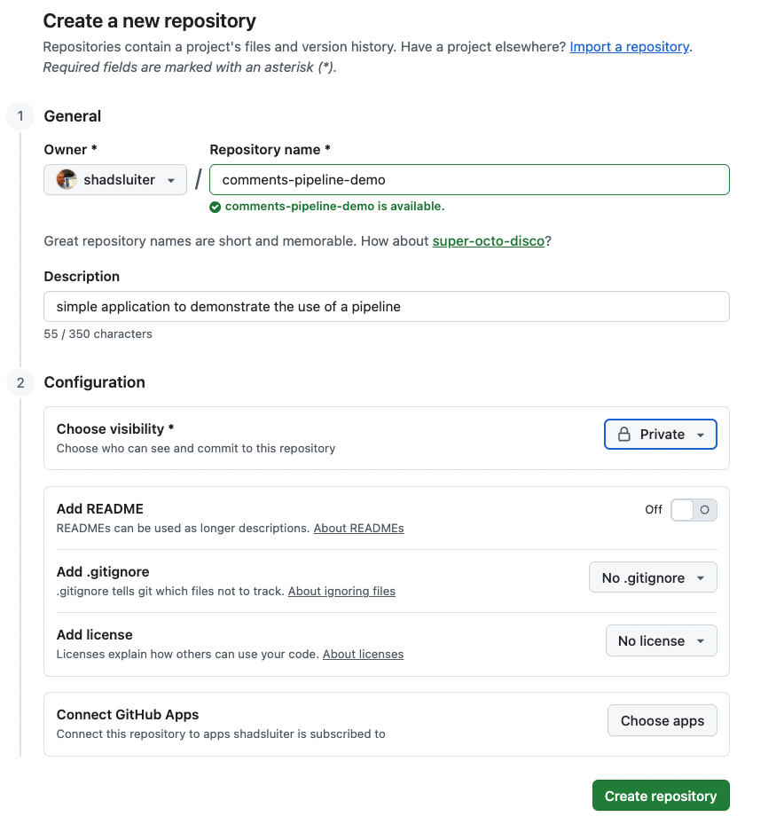
Figure 2 Creating a new repo on Github
- Create the repository
- GitHub now shows you instructions for connecting a local project
— keep this tab open.
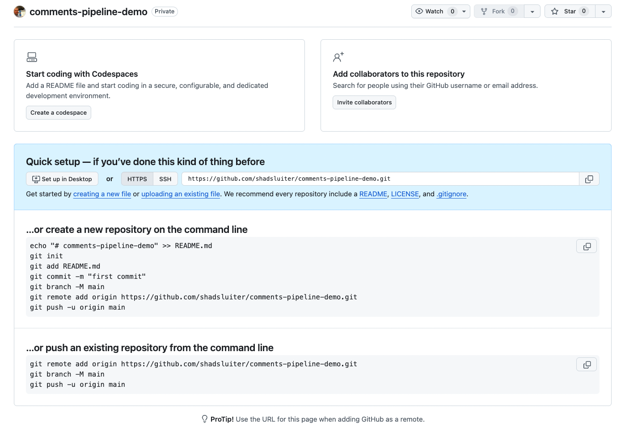
Figure 3 Instructions for command line statements to run on your computer.

Step 4 — Initialize Git in the Local Project Folder
You might be tempted to use the VS Code buttons shown below but the instructions for command line statement from GitHub are probably better.

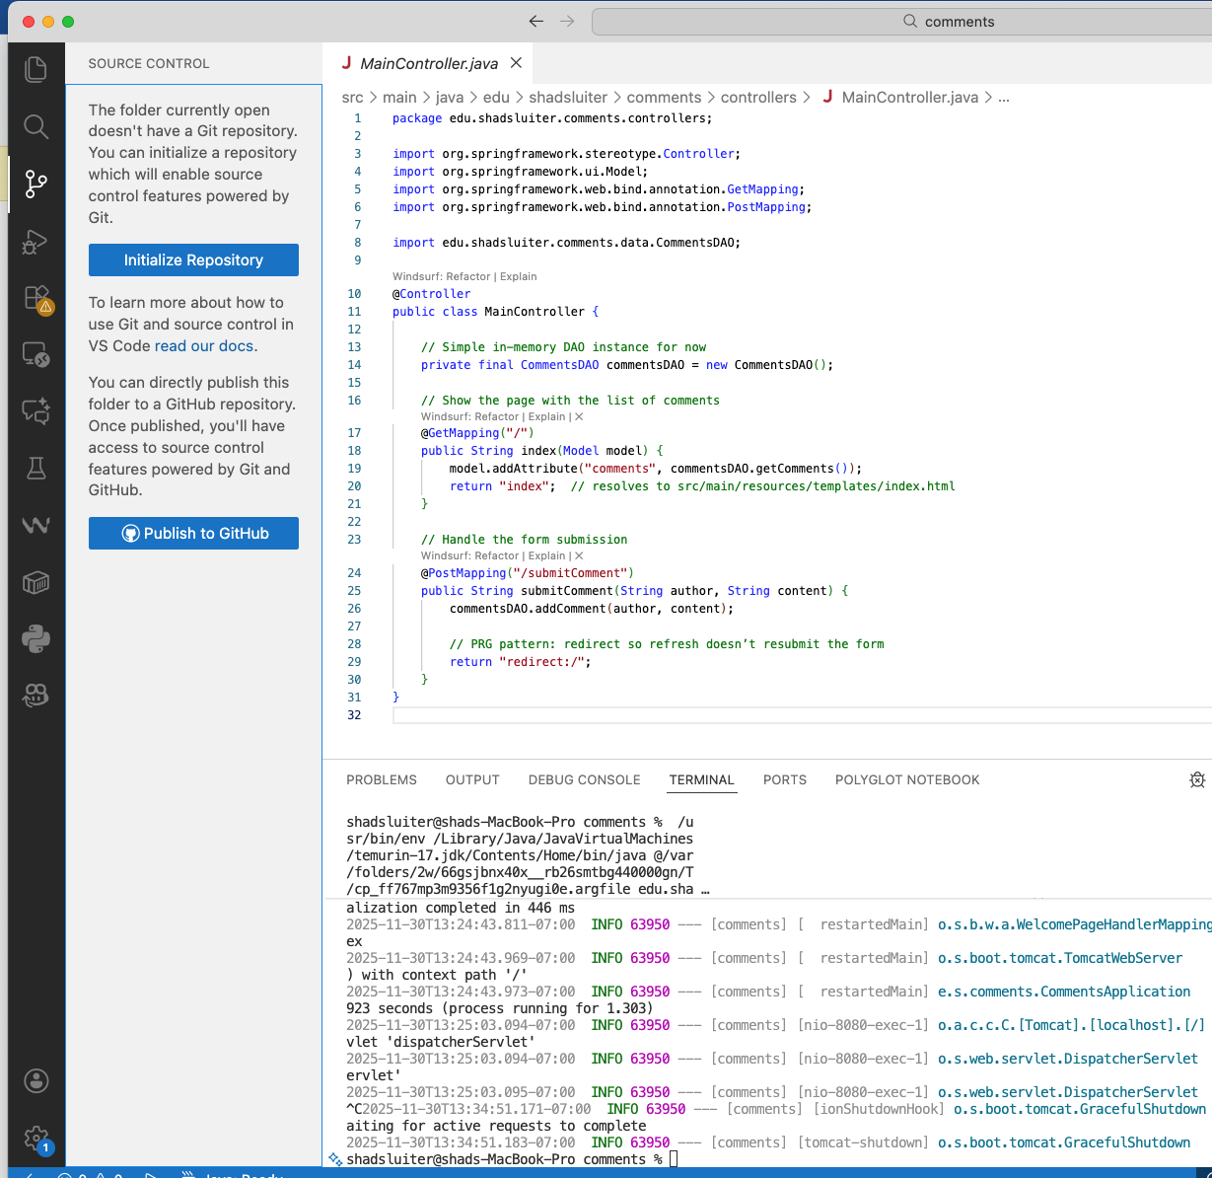
Figure 4 The Source Control tab in VS Code shows buttons to manage repositories. However, we will use command line statements to avoid potential errors.

Why Command Line Is Better for this tutorial
We could use the buttons provided in VS Code but the instructions will use command line statements instead for the following reasons.

1. The VS Code buttons behave differently based on environment
- Sometimes the buttons auto-create a GitHub repo with a random name.
- Sometimes the buttons initialize a repo in the wrong folder.
- Sometimes they create repos as private without telling the developer.
- You might not see what VS Code did behind the scenes.
This pipeline requires exercise requires:
- predictable repo names
- predictable remotes
- predictable branches
- a known local path
- no nested repos
VS Code buttons hide all the details which is the exact opposite of what we want for CI/CD.

Command Lines
From VS Code terminal or your OS terminal:
cd <folder-containing-starter-project>
git init

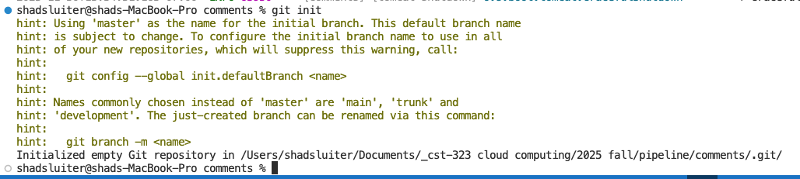
Figure 5 Git init is run from the command line
You now have a local Git repository but it contains no files and is not connected to GitHub yet.
You should observe a list of unpublished files, some git files that manage the repo.

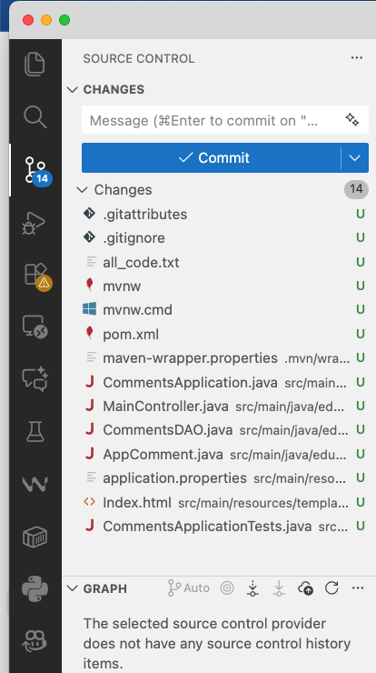
Figure 6 Source code section from VS Code after running init command.

Understanding What You See in VS Code Source Code Window
When you run the command:
git init
your project folder becomes a Git repository. VS Code detects this automatically and updates the Source Control panel on the left. You will now see a list of all the files in your project with a letter U beside each one.

What the “U” Symbol Means
U = Untracked
This means:
“Git sees this file, but it is not being tracked yet.”
Right after git init, Git starts with:
- 0 tracked files
- 0 commits
- your entire project is considered “new” to the repository
In the next steps you will stage and commit your files, the “U” symbols will disappear.

Local Initialization vs. GitHub
When you run the git init command, you are only creating a local Git repository on your computer. This step does not communicate with GitHub in any way, and nothing on GitHub.com changes as a result. At this point, your project is being tracked only on your local machine, and Git has no knowledge of any remote repository. A connection to GitHub is not created until you explicitly add a remote link with the git remote add origin <URL> command. Until that link exists, GitHub remains completely unaware of your project, and your code will not appear online. This distinction is important: git init affects only the local project. GitHub is not involved until you link and push.

Why All These Files Appeared
Git scanned your project folder and found all the files that make up your Spring Boot application, such as:
- .gitattributes — Git settings (e.g., line endings)
- .gitignore — tells Git which files/folders to ignore
- pom.xml — your Maven project definition
- mvnw / mvnw.cmd — Maven wrapper scripts
- src/main/java/... — your Java source code
- src/main/resources/templates/index.html — your web page
- src/test/java/... — your test files
Every one of these files is listed as U (Untracked) until you add them to the repository.

Staging and Committing Your Files
Right now, Git sees all the files in your project, but it is not tracking any of them yet. To save the current state of your project into your local Git history, you must complete a two-step process:
1. Stage the files
git add .
This command tells Git:
“Please include all files in this folder in the next snapshot.”
Nothing has been saved in the repo yet, but Git now knows which files you intend to record.
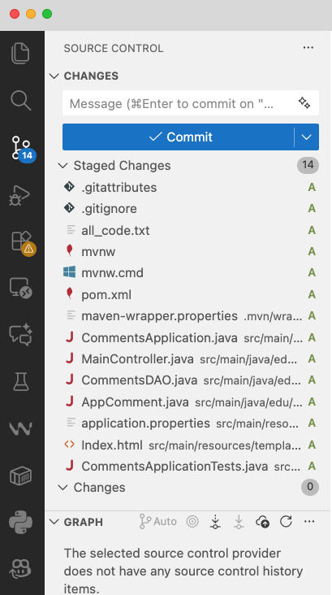
Figure 7 Project files after git add . command

What You’re Seeing After Running git add .
When you run:
git add .
you tell Git:
“Stage all files in this folder so they are ready to be committed.”
VS Code reflects this by moving all the files from Untracked (U) status into the Staged Changes area.

What the “A” Means
Each file now shows an A beside it.
A = Added (staged for commit)
This means:
- Git is now tracking these files
- They are included in the next commit
- They will be saved into Git’s history once you run git commit
Before this step, the files were marked U = Untracked
Now they are A = Added

What “Staged Changes (14)” Means
This label shows:
- 14 files were staged
- All 14 files will be included in the next commit
- Git is waiting for you to finalize this snapshot
It’s like gathering pages onto a desk before stapling them together.

2. Commit the files
git commit -m "Initial commit for the starter application"
This creates your first official snapshot, called a commit. A commit is like saving a version of your project into Git’s history with a message explaining what you did. In this case, “Initial commit” tells you (and anyone else) that this was the starting point of the project.

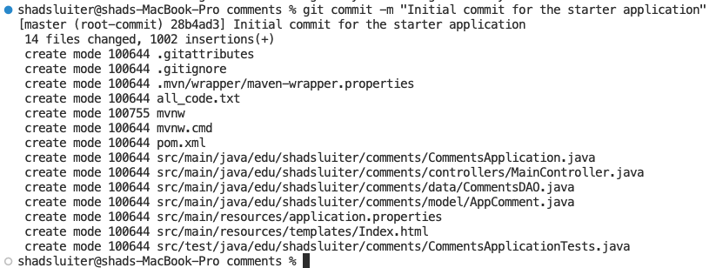
Figure 8 Command line results of a commit

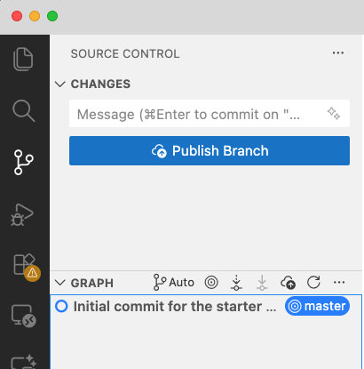
Figure 9 Empty changes section for file management.

What you should notice in the source control window.

CHANGES panel is empty
This means:
- “There are no unstaged or uncommitted changes.”
- In other words:
- You staged your files
- You committed your files
- Nothing left to commit
This is a clean working tree, exactly what you want after a commit.

The “Publish Branch” button appears
This button appears because:
- You have created a local commit
- But your repository still has no remote connection
- GitHub is not linked yet
- VS Code detects this and offers to publish it for you
This is VS Code’s way of saying:
“Your commit exists only on your computer. Do you want to upload (publish) it to GitHub?”
Since this lab is teaching Command Line Git, you should not click this button.
Instead, you will run more command line statements shortly.

Bottom left shows the branch: master
This tells you the name of the local branch you committed to. Some systems default to master; others default to main.
Rename to main. At the terminal, type:
git branch -M main

Why We Standardize the Default Branch Name to main
Historically, Git used master as the default branch name. Since 2020, GitHub moved toward using main as the default branch. This change helps avoid language that can be associated with master/slave terminology, which has negative historical connotations related to the enslavement of people.
git branch -M main
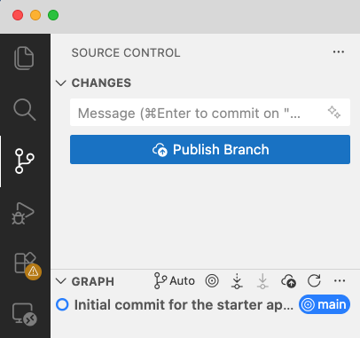
Figure 10 Main is the name of the branch

Graph view shows your first commit
At the bottom, you can see:
Initial commit for the starter ...
(main)
This means:
- You successfully created your first commit
- It exists locally
- It has not been pushed to GitHub yet

Why is a commit message necessary?
Because Git projects often have hundreds or thousands of changes, and you need a way to understand them quickly. Messages like:
- “Added timestamps”
- “Created table layout”
- “Fixed CSS styling”
- “Updated pipeline configuration”
help you know what changed without reading the entire codebase.

Why the quotes?
Git reads whatever is inside the quotes as one complete message, even if it contains spaces. Without quotes, Git would think each word is a separate argument and would produce an error.

Important notes about a local repo
- These changes are still only on your computer.
They are not on GitHub yet.
- A commit is like saving a project version into Git’s local database.
- After this step, Git begins tracking your files for changes.

Git Hub Commands Summary
Purpose | Command | Notes
Initialize Repository | git init | Start Git in the current folder (local only).
Check Status | git status | Shows modified, staged, and untracked files.
Stage All Changes | git add . | Adds everything in the working directory.
Stage Specific File | git add path/to/file | Use when committing only specific files.
Commit Changes | git commit -m "message" | Write short, clear messages.
Rename Branch to main | git branch -M main | Standardizes your default branch.
View Branches | git branch | Lists all branches; shows current branch.
Create + Switch Branch | git checkout -b feature | New branch for new work.
Switch Branches | git checkout main | Move between code branches.
Connect Local to GitHub | git remote add origin URL | Links your project to GitHub.
View Remotes | git remote -v | Confirms GitHub link.
First Push to GitHub | git push -u origin main | Sets upstream tracking for main.
Push New Commits | git push | Sends your commits to GitHub.
Pull Latest Changes | git pull | Retrieves updates from GitHub.
View Commit History | git log | Full chronological commit list.
Compact History | git log --oneline | One-line summary per commit.
See Unstaged Changes | git diff | Compare working directory → last commit.
See Staged Changes | git diff --cached | Compare staging area → last commit.
Unstage a File | git reset HEAD path/to/file | Keeps edits but removes from staging.
Discard Local Changes | git checkout -- path/to/file | Dangerous: overwrites local edits.
Amend Last Commit | git commit --amend | Fix message or add forgotten files.
Show Short Status & Branch | git status -sb | Quick overview of branch + status.

When Should You Make a New Commit?
A good developer commits early and often. Each commit should represent a small, meaningful change that you might want to understand or roll back later.
Below are guidelines and examples to help you choose the right moments.

Good Times to Commit (recommended)

1. Run a commit only after your project successfully compiles
- “Project builds without errors”
- “Initial project structure is in place”
This ensures you always have a working version to return to.

2. After completing a small feature
Examples:
- “Added CSS styling to main page”
- “Created new API endpoint for comments”
- “Added timestamp column to comments table”
- “Implemented input validation for comment form”
Small features → small, clear commits.

3. After fixing a bug
Examples:
- “Fixed null author bug in comment submission”
- “Corrected date formatting logic”
- “Resolved layout issue on mobile view”
Bug fixes should be isolated so they’re easy to trace.

4. After reorganizing or cleaning up code
Examples:
- “Refactored CommentsDAO for clarity”
- “Renamed variables for readability”
- “Moved CSS into external stylesheet”
Refactors deserve their own commits because they change structure, not behavior.

5. After adding documentation or comments
Examples:
- “Added Javadoc to MainController”
- “Updated README to explain project setup”
Non-code changes are still meaningful project improvements.

Poor Times to Commit (avoid)

1. A huge lump commit after finishing everything
Example:
- “Working application”
- “All features added”
- “Big update”
This makes it impossible to understand what changed or why.

2. When your project does not compile
Unless you are working on a branch and trying to checkpoint work, you should not commit broken code.

3. When you haven't made any meaningful change
Avoid “noise commits” like:
- “updated file”
- “just testing”
These clutter your history.

Why Smaller, Focused Commits Are Better
- Easier to understand history
- Easier to undo (restore a single feature, not everything)
- Easier to isolate bugs
- Cleaner pull requests
- Better for automated CI pipelines
A commit should be like a chapter in a book:
short, clear, and about one specific thing.

Step 5 — Link the Local Project to the Remote Repo
Copy the HTTPS URL from GitHub.com
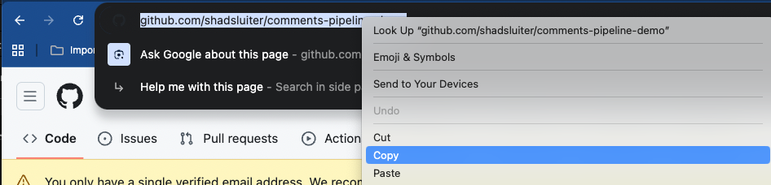
Figure 11 Copy the browser URL for your repo.
Then at the command line run:
git remote add origin https://github.com/<your-username>/<repo-name>.git
This command links your local repo to the online version.

What “remote” and “origin” Mean in Git

Remote
A remote is simply a link to a repository stored somewhere else, usually on GitHub.
When you work on code locally, Git needs to know where to send your commits when you push them online. That destination is called a remote.
Think of it like adding a contact in your phone:
- The person is “GitHub”
- The phone number is the repo URL
(https://github.com/shadsluiter/comments-pipeline-demo)
- Adding the contact = adding a remote
- You can have many remotes (GitHub, GitLab, Bitbucket, etc.), but most projects use just one.

origin
origin is simply the default name Git uses for the main remote repository.
It’s not a special keyword — it’s just a label.
You could call it github or cloud or pizza, but the worldwide convention is:
origin = the main GitHub repo
So when you run:
git remote add origin https://github.com/shadsluiter/comments-pipeline-demo
you are saying:
“Add a remote connection and call it origin, and here is the URL where the project will live.”

Why is origin the Default Name?
When you clone or link a GitHub repository, Git automatically names the remote origin because:
It represents the “original source” of the code.
It helps you mentally separate “where the code came from” from “what you are working on locally.”

The Mental Model “Origin” Is Meant to Create
Think of origin as:
- the home base
- the source of truth
- the canonical copy
- the place the project originally came from
- the authoritative online repository
In other words:
“origin is the original, authoritative location of this project on the internet.”
Your local machine is a clone or working copy of that origin.
This mental model helps us understand:
- where we push changes
- where team members pull changes
- where CI/CD pipelines listen for updates

Why not call it “GitHub” or “remote”?
Because in 2005 when Git was created:
Git needed a default name for the main remote repository. It had to work even if the remote wasn’t GitHub (GitHub didn’t exist yet!) Developers often cloned from shared servers, USB keys, or internal networks. The term origin was neutral and meaningful everywhere. origin has stuck ever since because it is short, descriptive, universal and instantly recognized by all developers
The word “origin” may sound like it should refer to the local project, because that’s where the you created or downloaded the code. But in Git’s world, origin always refers to the online location — even if the student created the code locally first.

Why “origin” Refers to GitHub (Remote) — Even If the Code Started Locally

Git is naming the remote repository, not where the files physically originated.
The intended mental model is: “origin = the authoritative location of the project, where collaboration and history live.”
Even if you wrote the code on your laptop first, as soon as you push to GitHub:
- GitHub becomes the “home base”
- GitHub becomes the system of record
- GitHub is where commits accumulate
- GitHub is where CI/CD pipelines run
- GitHub is where backups exist
- GitHub is where the team shares code
So Git calls the remote repository “origin” because it becomes the source of truth, not because it was the chronological origin of the files.
The Better Mental Picture
Instead of thinking:
“origin = where the files originated”
Think this way:

“origin = the original/trusted online location for this project.”
Even if the very first commit happened locally, the online repo becomes the “origin” from Git’s perspective.
Git’s naming is about authority, not chronology.

Verify it worked:
git remote -v
You should see:
origin https://github.com/<your-username>/<repo-name>.git (fetch)
origin https://github.com/<your-username>/<repo-name>.git (push)

Figure 12 Verified that an online repot is associated with the local repo.

Git Status
run git status before push. It will give information about the repo.

Push:
git push -u origin main

Understanding the push command:
This command sends your local commits to GitHub for the first time and also sets up a long-term connection between your local branch and the remote branch.
git
This calls the Git program. Everything you type after this tells Git what action to perform.
push
This means:
“Send my local commits to a remote repository.”
You use push when you want to upload your work to GitHub.
-u
This flag means set upstream.
It tells Git:
“Link my local branch to the remote branch so that future pushes and pulls know where to go.”
After using -u once, you can type simply:
git push
git pull
without specifying any branch or remote.
Think of -u as “remember this connection.”
origin
This is the name of the remote repository on GitHub.
Earlier you added this with:
git remote add origin <URL>
So now Git knows that:
origin = your GitHub repo
(https://github.com/<username>/<repo>)
main
This is the branch you are pushing.
You created your first commit on the main branch (or renamed it to main), so now you push that branch to GitHub.

More About Branches and Why You Push Main

What is a branch?
A branch is a separate line of development inside a Git repository.
It allows you to work on new features, experiments, or fixes without affecting the primary working version of the application.
Think of branches as:
parallel universes of your code
isolated workspaces
safe practice zones
All branches share the same history up to a point and then may diverge.

Why You Push the main Branch Here
In this class:
You created your first commit on main
You are setting up an automated CI/CD pipeline
GitHub Actions is configured to run on pushes to main
This means:
The “release-ready” version of your code lives on main,
and pushing to main triggers the automated build and deployment.
For a beginner pipeline, we keep everything on main for simplicity.

Would You Push Another Branch?
Yes. In many real-world projects, developers often push multiple branches.
Examples:

1. Feature branches
feature/add-timestamps
feature/improve-css
feature/search-bar
Used to develop new features safely.

2. Bug fix branches
bugfix/form-validation
bugfix/null-author-crash
Used to fix issues without breaking other work.

3. Experiment branches
experiment/new-layout
try-react-ui
Tests or prototypes.

4. Release branches
release/v1.2.0
Used when preparing for deployment.

What Happens After Pushing Another Branch?
When you push a non-main branch:
git push origin feature/add-timestamps
GitHub will show:
a new branch in the repo
an option to create a Pull Request
the ability to review and merge changes back into main
This is standard team workflow.

How CI/CD Usually Interacts with Branches
Your pipeline may be configured to:
Build + test all branches
Only deploy changes from main
Deploy only from release branches
Run checks on pull requests
This is common in professional DevOps setups.
For CST-323, we keep it simple:
main = deployment branch
We push to main to trigger the pipeline process

Putting It All Together
git push -u origin main
means:
“Send my main branch to the remote repository named origin, and remember this connection so future pushes and pulls happen automatically.”

After You Run This Once
You can now use a much shorter version of these commands such as:
git push
git pull
and Git knows:
- which remote to use (origin)
- which branch you’re working with (main)

Verify on GitHub
Return to your GitHub repo page and refresh. You should see all Spring Boot project files.

Screen Shot #2 – Git Hub Source Code Present


- Take a screen shot of current status of the application published to GitHub.
- Paste the image into a Word document.
- Put a caption below the image explaining what is being demonstrated.

Step 6 — Create a Dockerfile
You are creating a Dockerfile so GitHub Actions can build a Docker image automatically.
Create a new file in the project root (same level as pom.xml), named:
Dockerfile
Paste this into it:
# Use a Java 17 runtime
FROM eclipse-temurin:17-jdk

# Create a working directory inside the container
WORKDIR /app

# The JAR will be built by Maven into the target folder
ARG JAR_FILE=target/*.jar

# Copy the JAR produced by Maven into the image
COPY ${JAR_FILE} app.jar

# Spring Boot listens on 8080 by default
EXPOSE 8080

# Start the application
ENTRYPOINT ["java", "-jar", "app.jar"]
What this does:
Uses a Java 17 image (matches your Maven build)
Copies the JAR that Maven builds (whatever its exact name is) from target/
Runs java -jar app.jar when the container starts

Step 7 Create a GitHub secret called GHCR_PAT
Before GitHub Actions can push a Docker image to GitHub Container Registry (GHCR), it needs permission to do so. GitHub will not allow automated workflows to upload container images unless you explicitly grant access.
That is the purpose of creating a Personal Access Token (PAT) and saving it in GitHub as a secret named: GHCR_PAT

Why is the secret needed?
Your workflow will contain these steps:
- name: Log in to GHCR
uses: docker/login-action@v2
with:
registry: ghcr.io
username: ${{ github.actor }}
password: ${{ secrets.GHCR_PAT }}
GitHub Actions attempts to log in to the container registry (ghcr.io) using the GitHub username (github.actor) and a password stored securely in the secret GHCR_PAT
Without this secret, GitHub Actions cannot push your image, and the workflow will fail with authentication errors.

Why can’t we hard-code the token in the YAML file?
Because:
- it would expose your private token in the repository
- anyone could steal it
- it grants permission to push/delete container images
- GitHub automatically blocks workflows containing exposed PATs
- Secrets are encrypted and safe—only GitHub Actions can read them.

Steps:
- Go to GitHub → Profile (upper right)
- Settings
- Developer settings
- Personal access tokens
- Generate new token (classic)
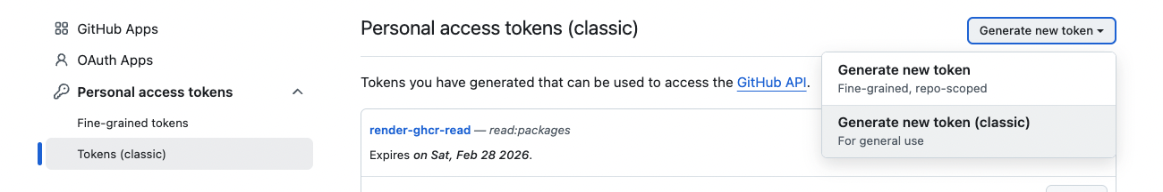
Figure 13 Creating a new token

- Select scopes:
write:packages
read:packages

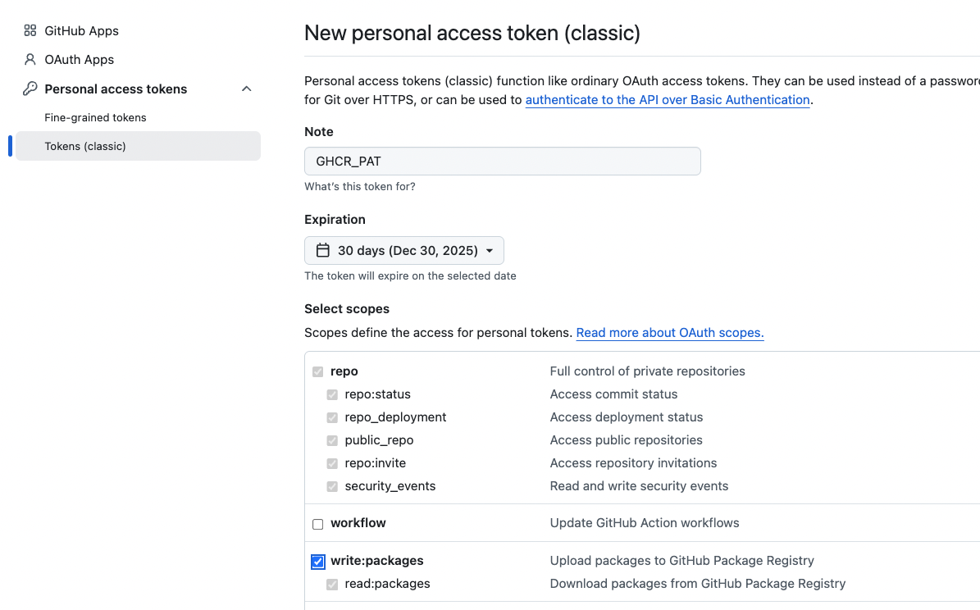
Figure 14 Selecting the Write and Read scope
Generate → copy.
Go to your repo → Settings → Secrets and variables →
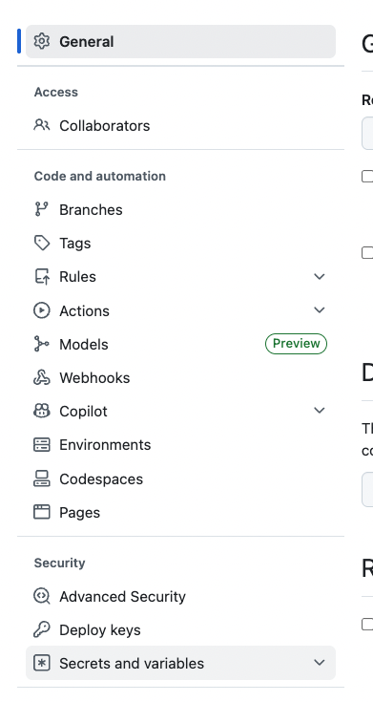
Figure 15 Location of Secrets

Actions
New repository secret:
Name: GHCR_PAT
Value: <paste token>

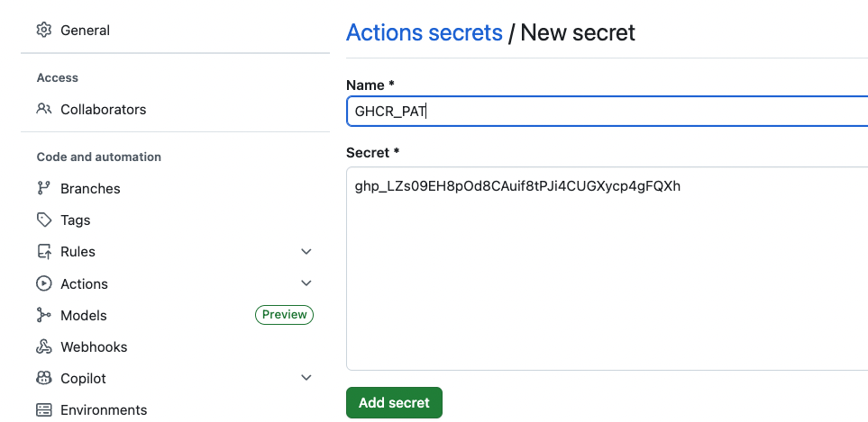
Figure 16 Secret label and content. Your secret will be different.

Commit and push the Dockerfile
Now that the Dockerfile and secrets are configured, we can add the new file to the repo.
From the project root:
git add Dockerfile
git commit -m "Add Dockerfile for containerized Spring Boot app"
git push

Step 8 — Add a GitHub Actions Workflow to Build and Publish the Container
GitHub Actions requires workflows to live in a hidden folder named .github/workflows. GitHub automatically scans this folder and runs any .yml files it finds.
Now that your project is stored in GitHub, it’s time to automate the creation of your Docker image.
GitHub Actions will:
- Build your Spring Boot app using Maven
- Create a Docker image using your Dockerfile
- Push the image to GitHub Container Registry (GHCR)

1 — Create the .github/workflows folder
If it doesn’t already exist, create:
.github/workflows/

2 — Create a workflow file named:
.github/workflows/build-and-push.yml

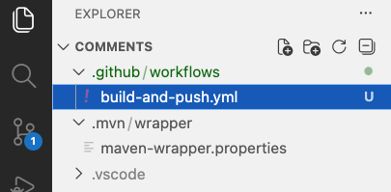
Figure 17 New yml file created in the appropriate folder

3 — Use this workflow file

Paste the following code first, then read the explanation below.
name: Build and Push Docker Image

on:
push:
branches: [ "main" ]

jobs:
buildandpush:
runs-on: ubuntu-latest

steps:
- name: Checkout code
uses: actions/checkout@v3

- name: Set up JDK 17
uses: actions/setup-java@v3
with:
distribution: 'temurin'
java-version: '17'

- name: Build Spring Boot JAR
run: mvn -B package --file pom.xml

- name: Log in to GHCR
uses: docker/login-action@v2
with:
registry: ghcr.io
username: ${{ github.actor }}
password: ${{ secrets.GHCR_PAT }}

- name: Build Docker image
run: |
docker build -t ghcr.io/${{ github.actor }}/comments-pipeline-demo:latest .

- name: Push Docker image
run: |
docker push ghcr.io/${{ github.actor }}/comments-pipeline-demo:latest

Explanation of What This Workflow File Does
on: push → branches: [ "main" ]
This tells GitHub:
“Any time someone pushes new code to the main branch, run this automation.”
This is what makes GitHub Actions feel “automatic.”
Job: buildandpush
A job is a group of steps that runs on a virtual machine.
Ours uses:
runs-on: ubuntu-latest
This means GitHub creates a temporary Linux machine in the cloud to run your tasks.
Step-by-step explanation of each step
Checkout code
uses: actions/checkout@v3
This downloads your project into the virtual machine.
Without this, the build machine would have no code to work with.
Install JDK 17
Spring Boot needs Java to compile.
uses: actions/setup-java@v3
with:
distribution: 'temurin'
java-version: '17'
GitHub installs Java on the cloud machine for you.
Build the Spring Boot JAR
mvn -B package --file pom.xml
This runs the same Maven build you run locally, but now inside GitHub’s servers.
This produces:
target/comments-0.0.1-SNAPSHOT.jar
Log in to GitHub Container Registry
This authenticates Docker so it can push to GHCR.
registry: ghcr.io
username: ${{ github.actor }}
password: ${{ secrets.GHCR_PAT }}

Build the Docker image
docker build -t ghcr.io/${{ github.actor }}/comments-pipeline-demo:latest .
Docker reads your Dockerfile, installs your JAR into a container, and prepares it for deployment.
Push the container
docker push ghcr.io/${{ github.actor }}/comments-pipeline-demo:latest
This uploads the container image to your GitHub Packages → Packages tab.
This is the container your cloud host (Render, Azure, AWS, etc.) will run.

4 — Commit and push this workflow
Now that the file exists, Git will detect it as a new file and we must commit it. Assuming you're in the root of your project folder (comments or comments-pipeline-demo):

Commands to Commit and Push the Workflow
git add .github/workflows/build-and-push.yml
git commit -m "Add GitHub Actions workflow to build and push Docker image"
git push

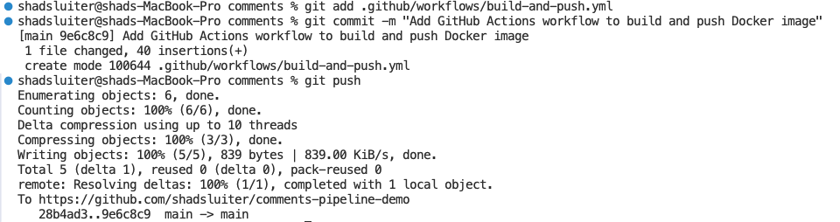
Figure 18 Expected results from commit and push

What each command does

Add the workflow file
git add .github/workflows/build-and-push.yml
Tells Git: “Track this new file.”

Commit with a message
git commit -m "Add GitHub Actions workflow to build and push Docker image"
Creates a new commit containing the workflow.

Push to GitHub
git push
Uploads the commit to GitHub and triggers the GitHub Actions pipeline automatically.

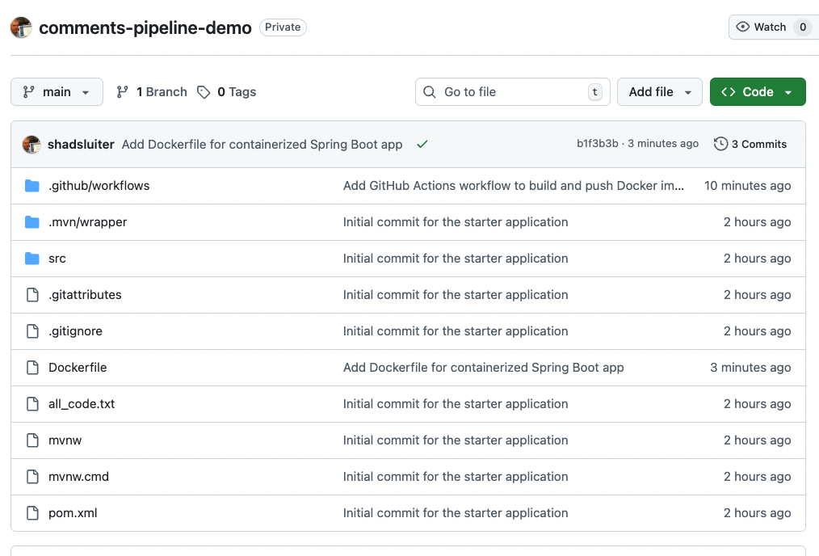
Figure 19 new Dockerfile has been added to repo.

Step 9 - Verify the action succeeded
Go to:
GitHub → Your Repo → Actions
You may see an action in the queue.

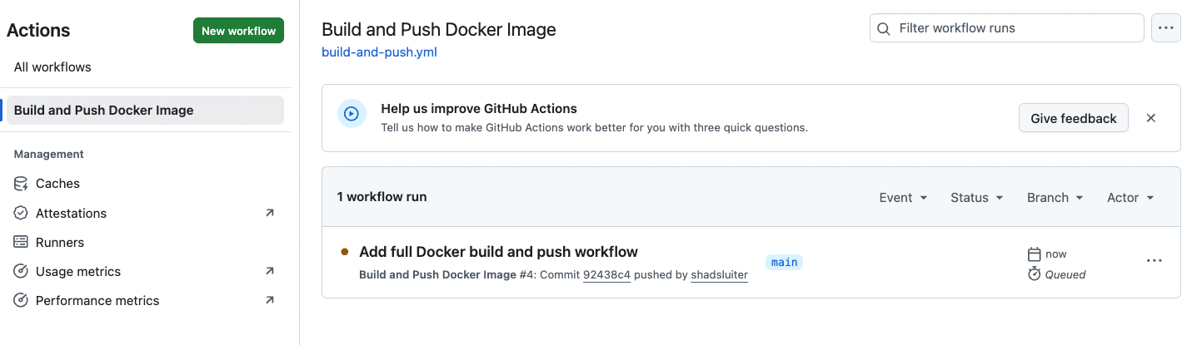
Figure 20 New action results
It should change to an action in progress.
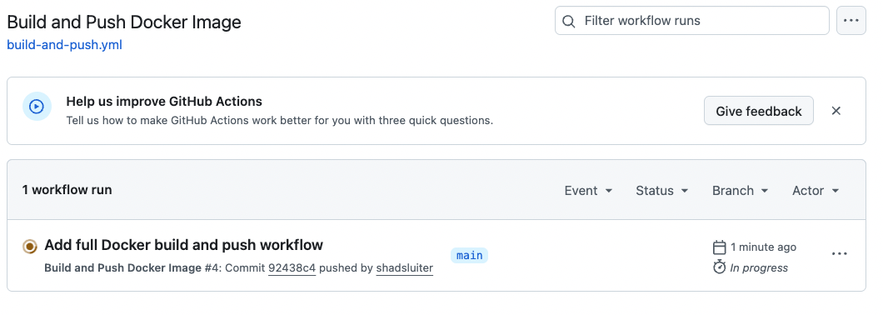
Figure 21 Action is in progress
You should see a successful build.
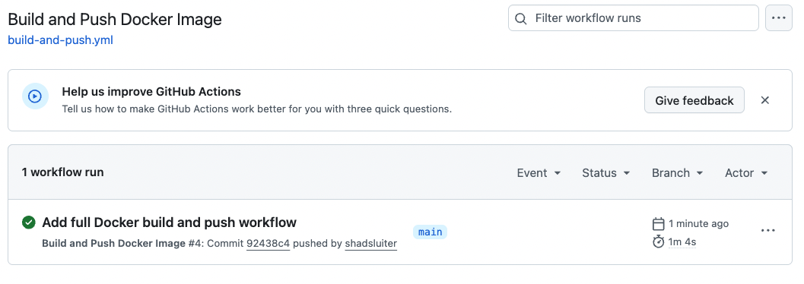
Figure 22 Completed action

If you see more than one package, it is because you ran the workflow under two different image names during testing. This is normal — you can delete older packages from GitHub Packages if desired.
Click on the title “Add full Docker build and push workflow”
You should see the job name listed as “buildandpush”. This name was defined in the YML file.

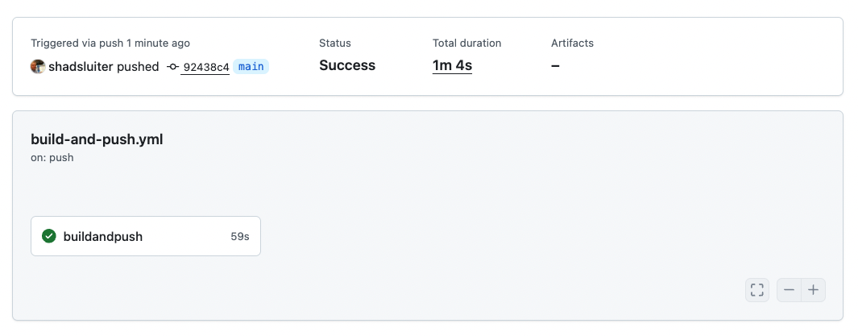
Figure 23 Details of the completed action
Click on “buildandpush” to see the nested tasks defined in the yml file.

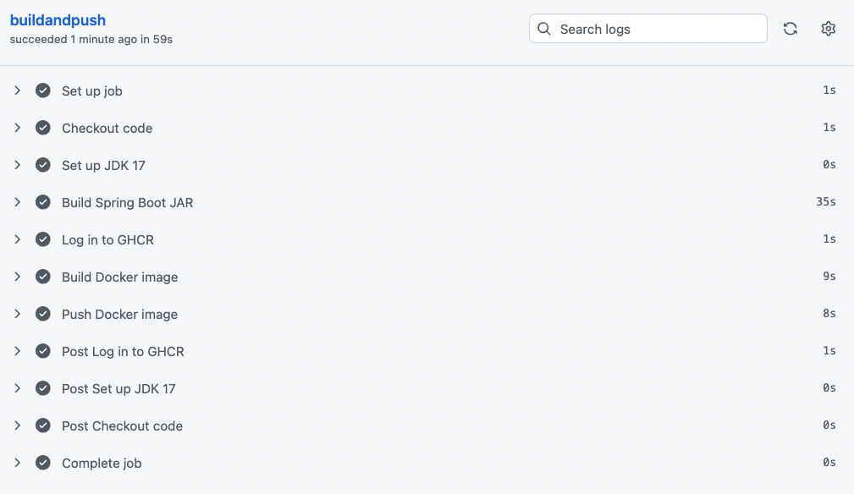
Figure 24 More granual view of action

Screen Shot #3 – Success Action Report

- Take a screen shot of current status of the application.
- Paste the image into a Word document.
- Put a caption below the image explaining what is being demonstrated.

Understanding What Just Happened in the Pipeline
When you trigger a GitHub Actions workflow, GitHub not your JDK on your computer builds the entire application. This is different from how you’ve been running projects locally.

Where Is the Build Happening?
When you run the pipeline, GitHub creates a temporary virtual machine (an ubuntu-latest runner) in the cloud. This virtual machine was defined near the beginning of the YML file as runs-on: ubuntu-latest
Inside that runner:
- It installs JDK 17
- It checks out your code
- It runs Maven to compile your Java project
- It packages your Spring Boot application into a JAR
- It runs Docker build to containerize the app
- It pushes the Docker image into GitHub Container Registry (GHCR)
This means:

Your computer does none of the building

GitHub’s cloud environment does all the compiling and packaging

The result is a deployable Docker image stored online

Did This Publish the App to the Cloud?
Not yet.
What you completed is:

Continuous Integration (CI)
Your code builds successfully, and a container image is pushed to a registry.
You have not done:

Deployment (CD)
The application is not live on a public URL yet.
To make the app available on the Internet, you must deploy the GHCR image to a hosting provider (Render, Azure, AWS, etc.) This tutorial will do that in a later step. So what you have produced is:

A verified, reproducible, portable application image that any cloud provider can now run.
Your app is now “deployment-ready.”

Common Errors You May Encounter during this phase

Checkout Code
Error: Repository not found / Permission denied
Cause: Pushing to a private repo without proper permissions in the workflow
Fix: Ensure Actions has access, or make repo public for the course.

Set up JDK 17
Error: Incorrect Java version
Cause: Using Java 21 locally but workflow installs Java 17
Fix: Align versions or update pom.xml compliance level.

Build Spring Boot JAR
Errors:
- "Dependency not found"
- "Compilation failed"
- "Tests failed"
Cause:
Your local environment may have artifacts cached—but GitHub does not.
If it fails here, the code truly cannot compile from scratch.
Fix:
Run mvn clean package locally before pushing.

Log in to GHCR
Error: Login failed
Cause: Missing or incorrect Personal Access Token
Fix: Ensure GHCR_PAT secret is created with write:packages scope.

Build Docker Image
Error: Dockerfile not found
Fix: Ensure the file name is exactly Dockerfile with no extension.
Error: "COPY failed: file not found"
Fix: Paths in Dockerfile must match the project directory structure.

Push Docker Image
Error: HTTP 401 — Unauthorized
Cause: Wrong registry path or missing permissions
Fix: Image name must follow this format:
ghcr.io/<github-username>/<repo-name>:latest

Summary
You just ran your first cloud-based build pipeline.
- The Spring Boot app compiled on GitHub’s servers
- Docker built a container image in the cloud
- The finished image was pushed to GitHub Container Registry
- The app is not deployed yet, but it’s ready for deployment
- This mirrors real DevOps workflows used in professional software teams.

Where the image is now
GHCR packages don’t show under repo Settings → Packages; instead they live under your user packages.
To see it:
- Go to the GitHub main page and clikc on packagaes.
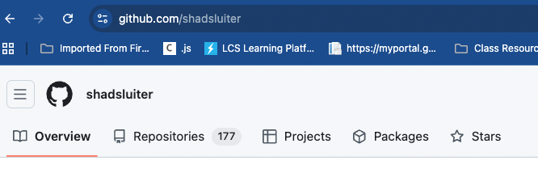
Figure 25 Main screen of user account on GitHub. Look for "Packages" menu
Or navigate directly to the packages folder.
https://github.com/users/yourname/packages
You should see a package called something like comments-pipeline-demo (the repo name from your docker build tag).

What Are “Packages” on GitHub?
The Packages tab is GitHub’s built-in container registry. This is where GitHub Actions pushes your Docker images after building them.
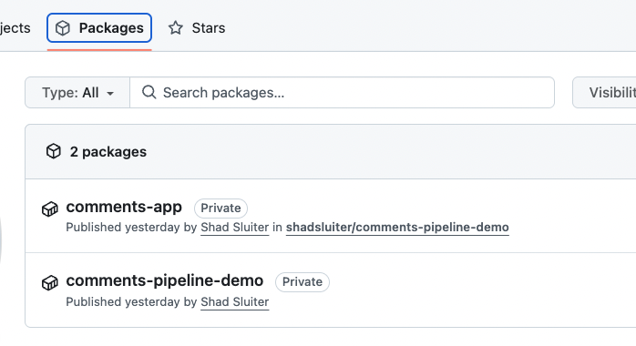
Each line represents a Docker image stored in GitHub Container Registry (GHCR).
Think of a GHCR package as:
the final, ready-to-run, “boxed-up” version of your application
created automatically by GitHub Actions
tagged and stored online so any cloud provider can run it

What’s Actually Inside a Package?
Each package contains:
- Your Spring Boot JAR
- The base image (e.g., Eclipse Temurin Java image)
- All your app dependencies
- The Docker metadata (tags, layers, manifest)
- Version history of every image you've pushed
It is your complete application now compiled, containerized, and ready to deploy.

These are the Containers We Deploy to a Cloud Service
Your workflow produced:
- A built Docker image
- Uploaded to GHCR
- Publicly accessible with a URL like:
ghcr.io/shadsluiter/comments-pipeline-demo:latest
Any cloud provider that supports Docker containers (Render, Azure, AWS, Railway, Fly.io, etc.) can deploy this image directly. This means you no longer deploy source code. Instead, you deploy a container.
Render.com can pull private GHCR images, but requires a Render Registry Credential setup that adds extra complexity. It is recommended to make your GHCR package public.

To make your GHCR image public:
- Go to GitHub → Packages
- Open your image
- Settings
- Visibility → Public
This avoids many errors later (“Render can’t pull image: 401 Unauthorized”).
You are now ready to Deploy your image on Render.com because GHCR has the container now.

Test end-to-end automated updates
In this section we will produce four incremental improvements to the app, deploy each of them and note the automatic updates. Each of these, v1, v2, v3, v4 changes trigger new builds.

Get more information about the action. Click the package name to view the contents and URL information.

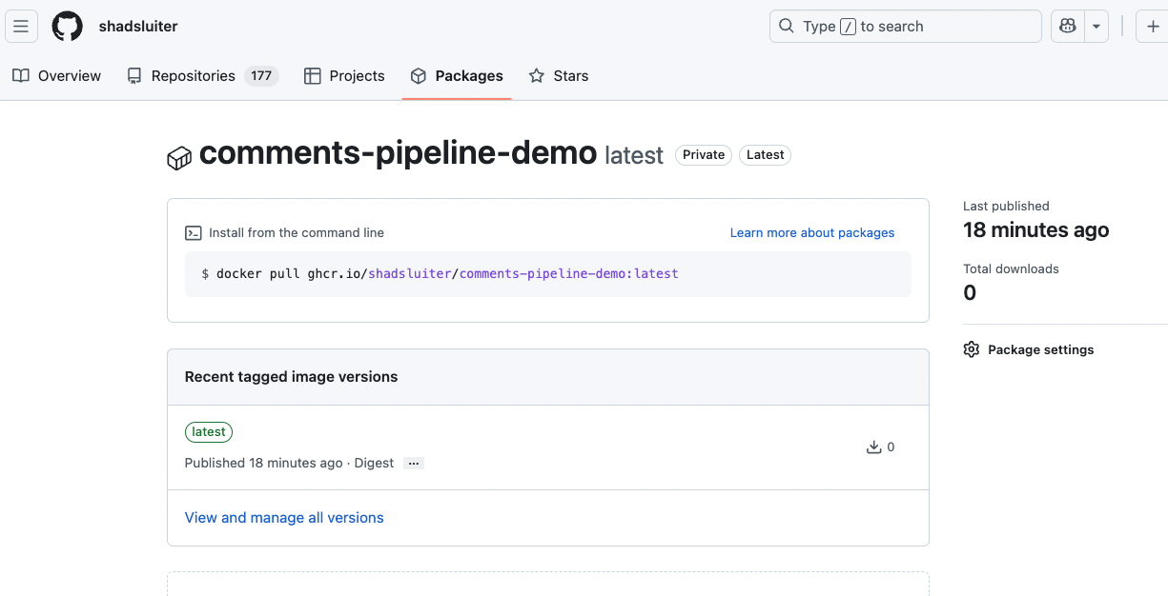
Figure 26 Details about the package

Part 6: Deploying the Container to an Online Host
From this point, you can deploy the container to any of the cloud services such as Azure, AWS or Google Cloud. For this example, we will use a free hosting platform called Render.

1. What is Render.com and why are we using it?
Render is a cloud platform that lets you deploy web apps and databases.
They offer a Free Web Service tier, which:
- lets you deploy a real web app without a credit card
- provides a public URL for your comments app with no cost and no payment method required.
- will “spin down” when idle and spin back up when visited (so first hit may be slow)
- may pause services if you exceed free limits for the month
Your pipeline will now look like this:
Developer → GitHub → GitHub Actions → GHCR (container image) → Render → Public URL

2. Sign up for Render and connect GitHub

Step 1 – Create a Render account
- Go to https://render.com
- Click Sign Up.
- Choose Sign up with GitHub (recommended).
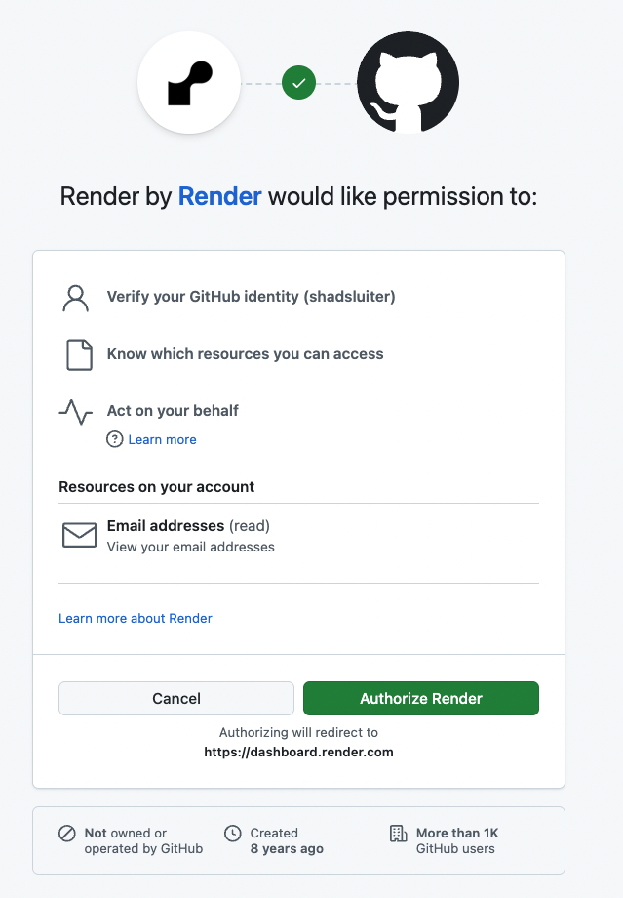
Figure 27 Permissions for Render and GitHub integration
- Authorize Render to access your GitHub repos (you can limit it to this repo if you prefer).
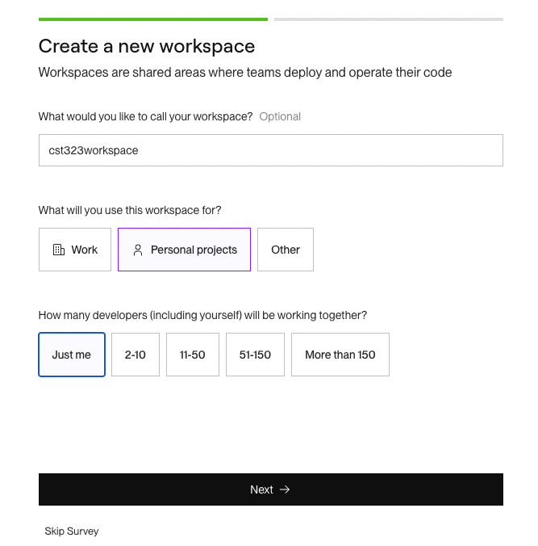
Figure 28 Options to select project scale
This does not give Render control over your code; it just allows them to read the repo or pull container images later.

3. Create a free Render Web Service using your container image
We’ll have Render deploy the Docker image that GitHub Actions pushes to GitHub Container Registry (GHCR).
Prerequisite: Know your image name
From earlier steps, your GitHub Actions workflow is tagging images like:
ghcr.io/<your-github-username>/comments-pipeline-demo:latest
You’ll use that in Render.

Start a new Web Service on Render

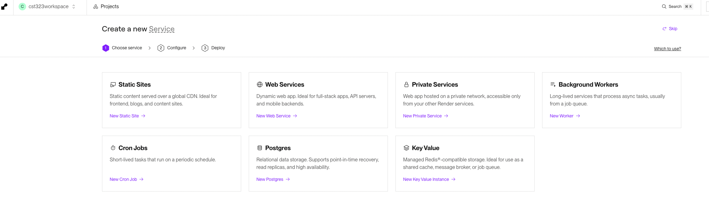

On this page, Render is asking: What type of service do you want to deploy?
We are deploying a dynamic web application (a Java Spring Boot app running inside a Docker container), so students should choose:
Web Services → New Web Service
This option supports:
- running a containerized backend
- exposing ports (e.g., 8080)
- auto-restarts
- environment variables
- free tier instance
Do NOT choose:
- Static Sites — only for HTML/CSS/JS (no Java, no containers)
- Private Services — require payment
- Background Workers — no incoming HTTP requests
- Cron Jobs — scheduled tasks
- Postgres / Key Value — databases
In the Render Dashboard, click New → Web Service.
When asked for the service source, choose:
Existing Image (not “from repo”)

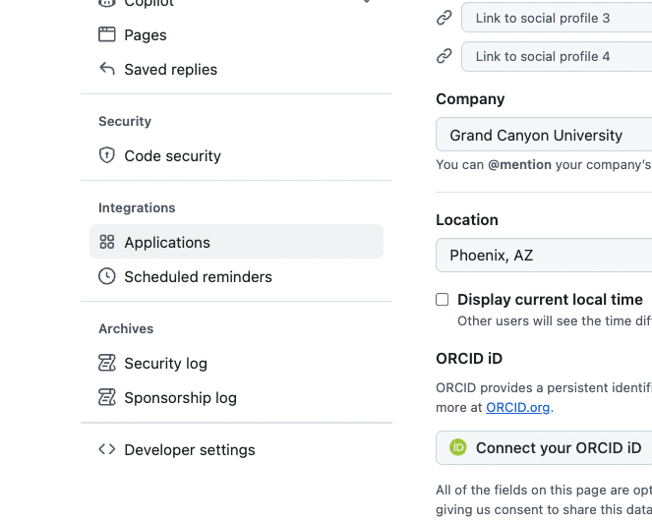
Figure 29 New options

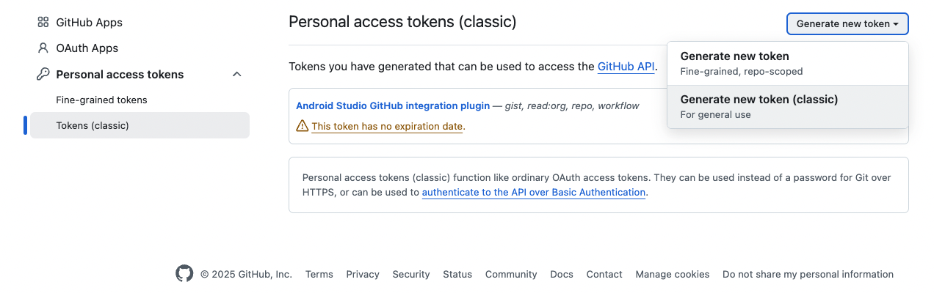
Figure 30 Selecting a new token

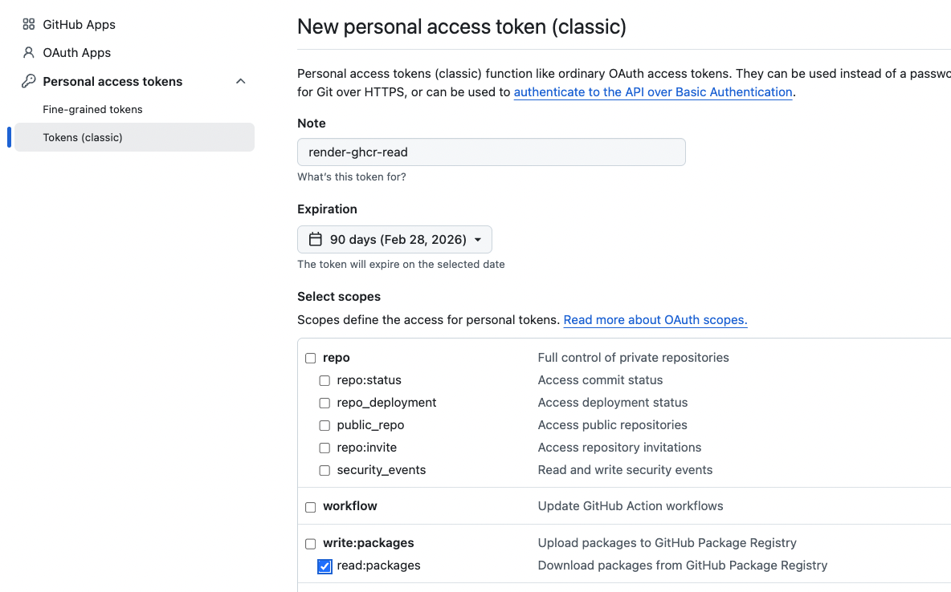
Figure 31 Read only permissions granted
This tells Render: “Pull a Docker image from a registry and run it.

- For Image URL, enter:
- ghcr.io/<your-github-username>/comments-app:latest

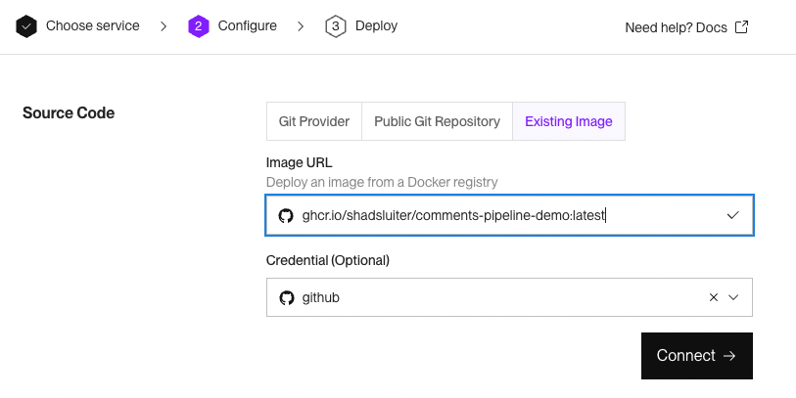
Figure 32 Render.com settings to connect to a GitHub container
Follow the defaults for a free application.
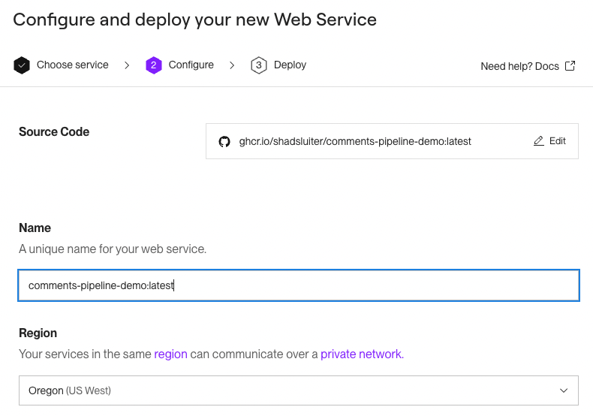
Figure 33 Unique name provided for the pipeline application
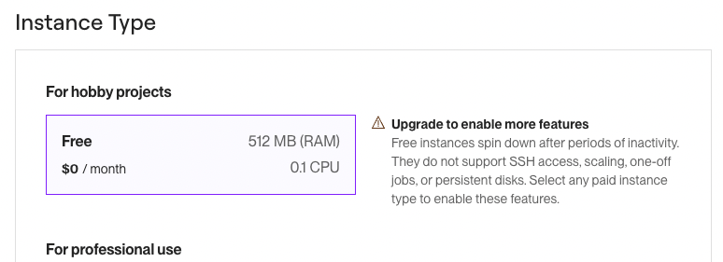
Figure 34 Selecting free option

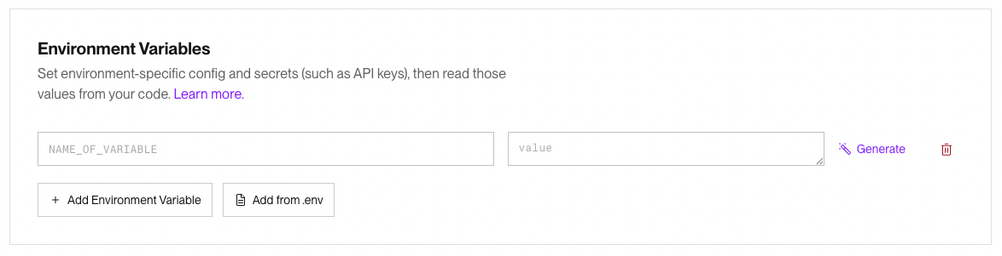

Why You Don’t Need Environment Variables (yet)
Your Comments application:
- uses no database
- has no external APIs
- does not require authentication keys
- does not use Spring profiles
- does not read any configuration from environment variables
Everything the app needs is:
- the Java code
- the in-memory DAO (CommentsDAO)
- the HTML template (index.html)
Render’s environment variables panel is optional and empty for apps like this.

Version 2.0
In a future version, someday, the comments application will use a database. Then, the application will need to connect to a MySQL or Mongo service. At that time you will need to provide:

1. Database Connection
SPRING_DATASOURCE_URL
SPRING_DATASOURCE_USERNAME
SPRING_DATASOURCE_PASSWORD

2. API Keys
OPENAI_API_KEY
STRIPE_SECRET_KEY
AWS_ACCESS_KEY_ID

3. Spring Boot Profiles
SPRING_PROFILES_ACTIVE=prod

4. Secrets that should NOT go in GitHub
Passwords, tokens, etc.
Your current app uses none of these.
Click Create Web Service.
Render will now:
- pull ghcr.io/<user>/comments-app:latest
- start a container
- show you a public URL, such as:
https://comments-app-abc.onrender.com

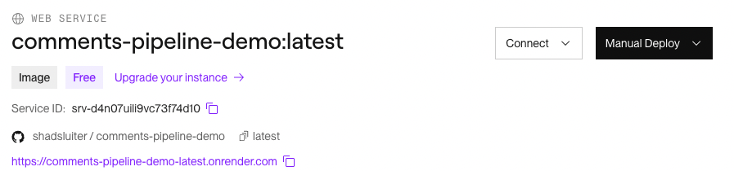
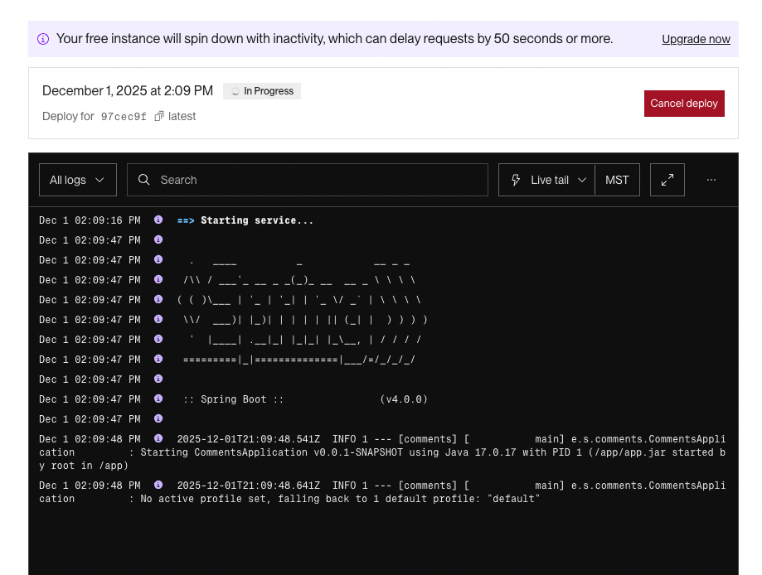
Figure 35 Application is being published to Render.com
The first deploy may take a couple of minutes.
Once it finishes, visit that URL. You should see your current version of the comments app.

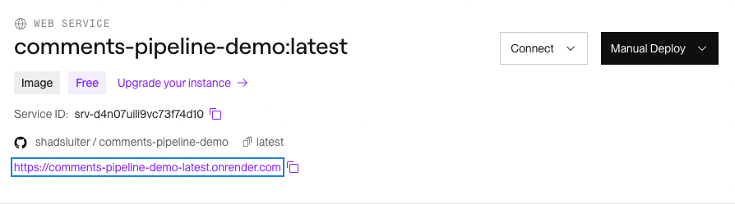
Figure 36 URL displayed for live application
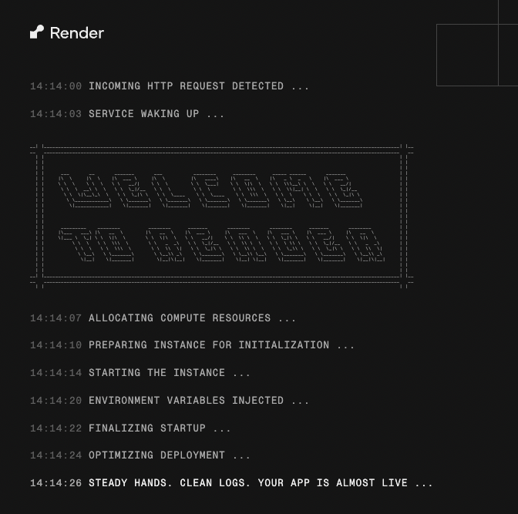
Figure 37 Render.com process to start an application is displayed
Eventually, the app will finish and go live. Fortunately, the log messages are easy to see, copy and diagnose if there is a problem.
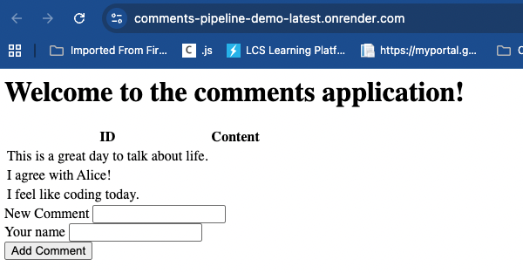
Figure 38 Live application online. Notice the URL is a public domain name.

Screen Shot #4 – Online Published App

- Take a screen shot of current status of the application.
- Paste the image into a Word document.
- Put a caption below the image explaining what is being demonstrated.

Updating the Application through v1, v2, v3, v4
Now the application is finally live, the next steps will be easier. We will incrementally add new features to the app.
Change code locally to implement v1: show comments in a table
Modify index.html to show 3 columns in the table. Id, comment and author name.

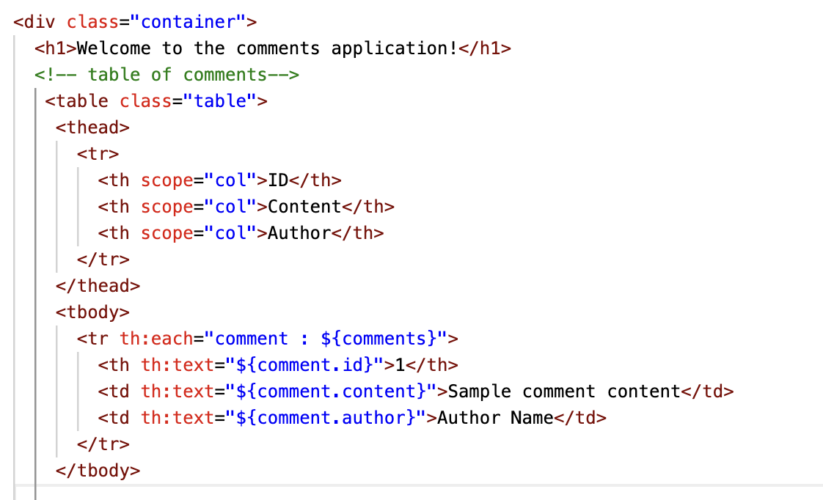

Commit and push to GitHub
git add .
git commit -m "v1: Display comments in a table"
git push
GitHub Actions pipeline runs
- checks out code
- runs mvn clean package
- builds a Docker image using Dockerfile
- pushes the image as ghcr.io/<user>/comments-app:latest

Wait for the build process to complete on GitHub.
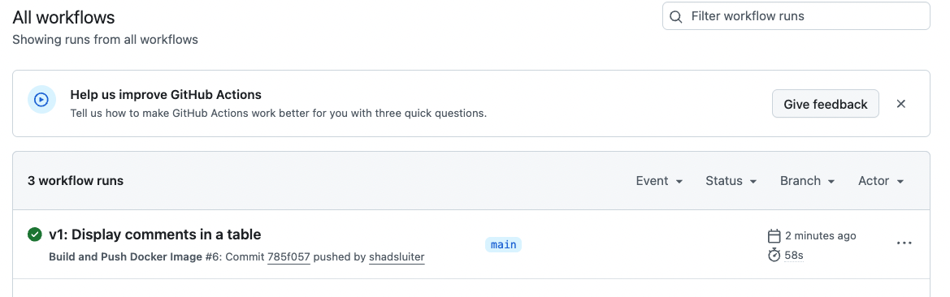
Render.com pulls the new image
Simplest approach:
- In Render Dashboard, select your service
- Click “Manual deploy → Deploy latest reference”

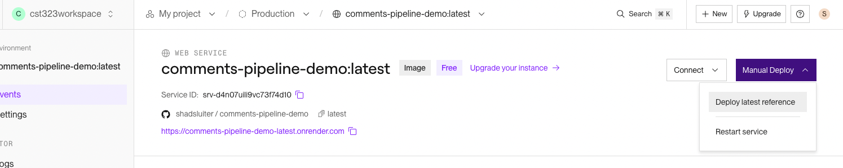
Shortly, we will automate this last step.
Visit the URL
https://comments-app-abc.onrender.com
The browser should show v1 changes (table layout) live on the internet
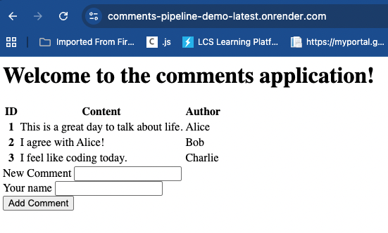
Figure 39 The online version of the app shows three columns in the table.
Figure 40 The entire table is now viewable on the live application
Making Render Automatically Deploy Your App After Every GitHub Push
So far, your CI/CD pipeline does the following:
- You push code to GitHub.
- GitHub Actions compiles the Spring Boot app, builds a Docker image, and pushes the image to GitHub Container Registry (GHCR).
- Render can run that container, but only if you manually click “Deploy” from the Render dashboard.
- Now we will complete the automation so that every time you push new code, Render automatically pulls the new container image and deploys it.
This final step closes the CI/CD loop and gives you a true automated deployment pipeline.

What Is a Render Deploy Hook?
Render gives each service a special Deploy Hook URL — a secret URL you can call from GitHub Actions.
When GitHub Actions sends a request to this URL:
- Render immediately triggers a new deploy
- Render pulls the newest :latest image from GHCR
- Your application is restarted with the updated container

Get Your Render Deploy Hook URL
Follow these steps carefully:
- Open your service on Render.com
- Click Settings
- Scroll to the Deploys section
- Locate Deploy Hook
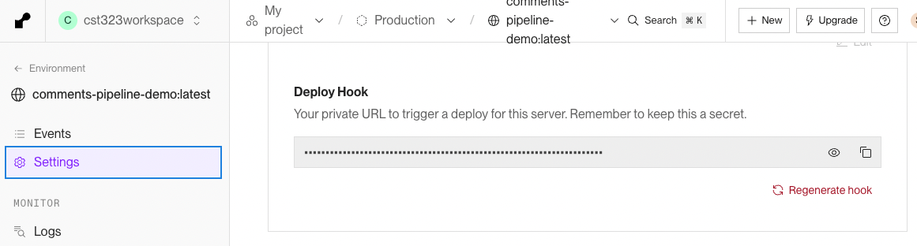
Figure 41 The Hook is a sensitive URL that should be kept private

- Copy the long secret URL (it looks like https://api.render.com/deploy/srv-xxxxx?key=yyyyy)
This URL allows GitHub to tell Render: “New container is ready — deploy it.”

Add the Hook URL as a GitHub Secret
We never paste secret keys into workflow files.
Instead, we store it securely in GitHub Secrets.
- Go to your GitHub repository
- Click Settings → Secrets and variables → Actions

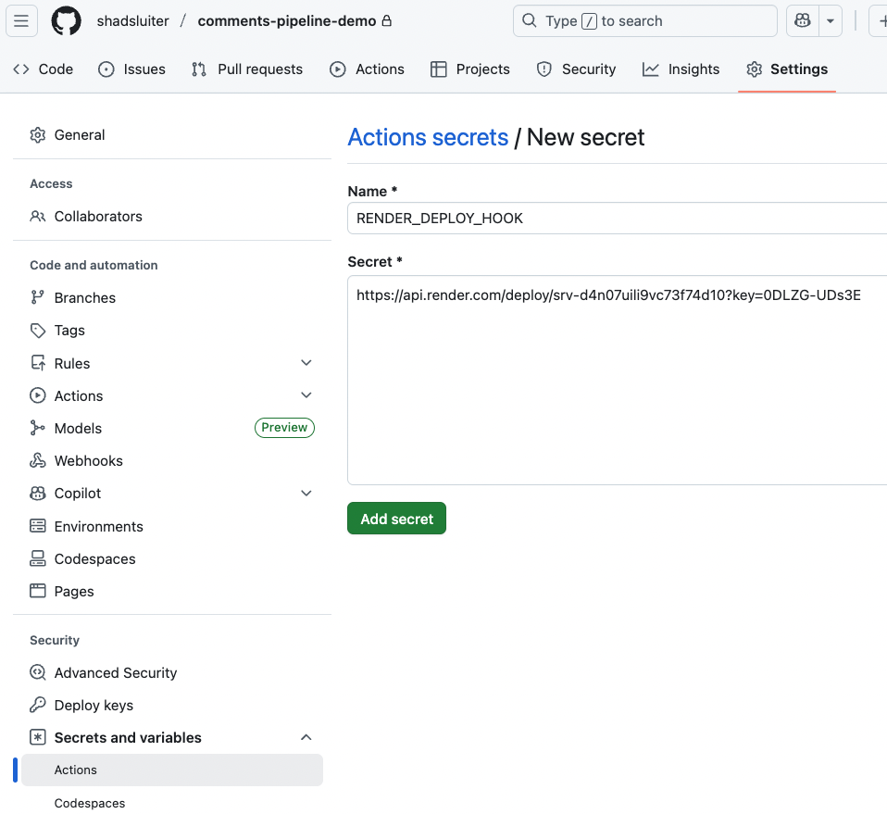
Figure 42 Copied URL is added to GitHub Secrets
Click New repository secret
- Name the secret:
- RENDER_DEPLOY_HOOK
Paste the Deploy Hook URL
- Click Add Secret
- Now the deploy hook is safely stored.
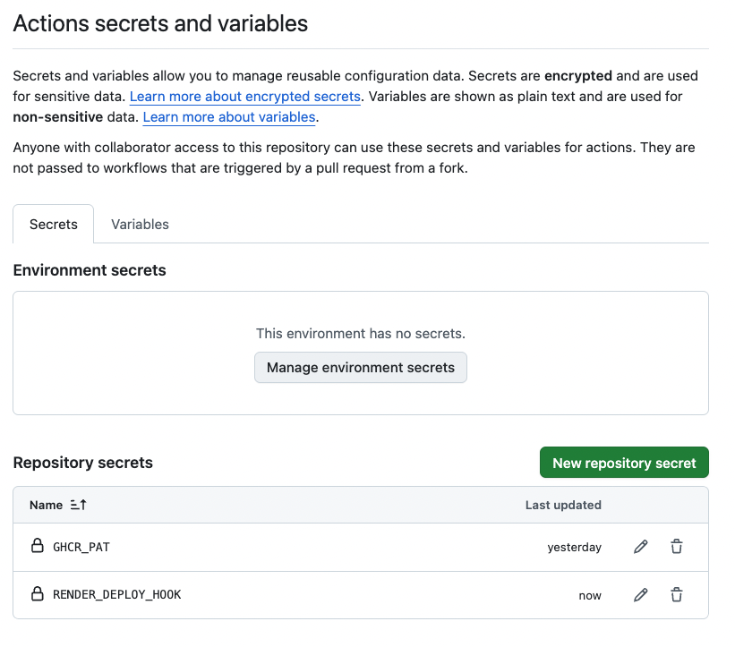
Figure 43 Secrets are listed in the GitHub profile

Update Your GitHub Actions Workflow
Open .github/workflows/build-and-push.yml and scroll to the end of the steps.
Right after pushing the Docker image, add this:
- name: Trigger Render deploy
env:
RENDER_DEPLOY_HOOK: ${{ secrets.RENDER_DEPLOY_HOOK }}
run: curl -X POST "$RENDER_DEPLOY_HOOK"

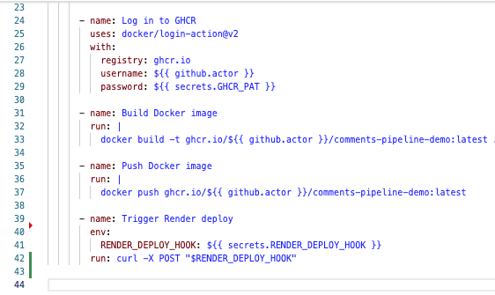
Figure 44 New item in the list of scripted events.
Note: Indent spaces matter! Ensure that the run and env words are vertically aligned.
This tells GitHub Actions:
- After the Docker image is pushed to GHCR
- Send a POST request to the Render deploy hook
- Render automatically deploys the new container

You now have full automation!
Whenever you:
git add .
git commit -m "Some update"
git push
The following happens automatically:
- GitHub Actions checks out your code
- Maven builds the JAR
- GitHub builds your Docker image
- The image is pushed to GHCR
- GitHub calls your Render deploy hook
- Render fetches the latest image
- Render deploys your updated application
- Your live URL refreshes with the latest version
- You never need to redeploy manually again.

Testing Full Automation
Next we will update the application three times to test the automated process.
In each version step
- Make the small code change
- Commit the new files using a descriptive message “v2 Added CSS style to index”, “v3 Added a timestamp to the comment”, “v4 added search feature in DAO and user interface”.
- Push to main
- Watch Actions run
- Watch the update in Render
- Refresh the public URL and confirm the new behavior

v2: CSS / styling update
- Create a style.css file
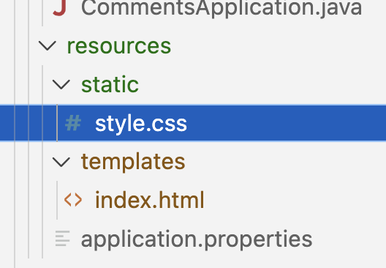
Figure 45 Adding a new css file to the static folder
- Create some style settings for the body, table, form and elements.
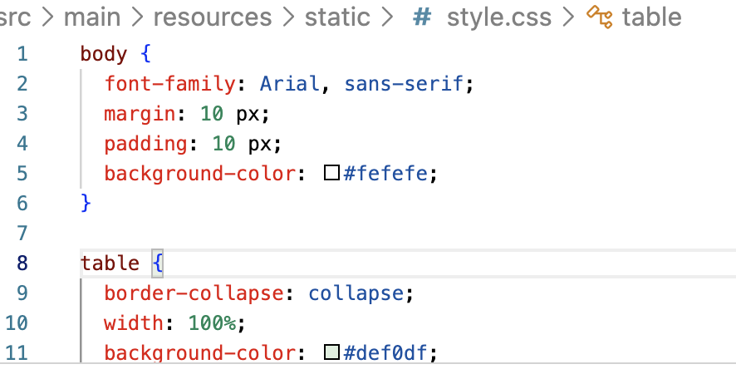
Figure 46 Starting suggestion for the CSS on the application. Customize and add your own

- In index.html, add a references to the css file.
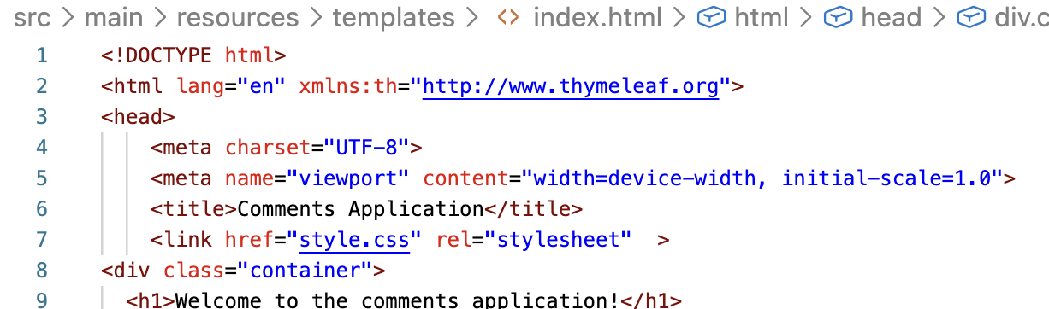
Figure 47 Reference to an external css file
- Run and test the application locally. Don’t commit changes to the Git repo until you are happy with the new look of the page.

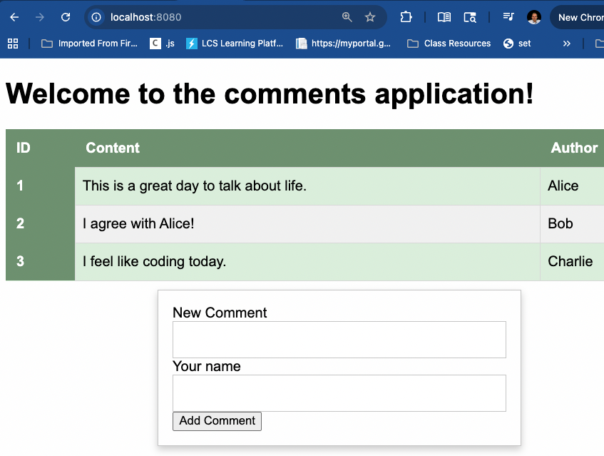
Figure 48 New CSS styles are visible in the localhost app

- When you are satisfied with the new changes, execute the appropriate Git commands to add, commit and push the changes.
- Verify GitHub actions by watching as the new change are compiled and accepted.
- Watch Render.com for new changes to be accepted and published.
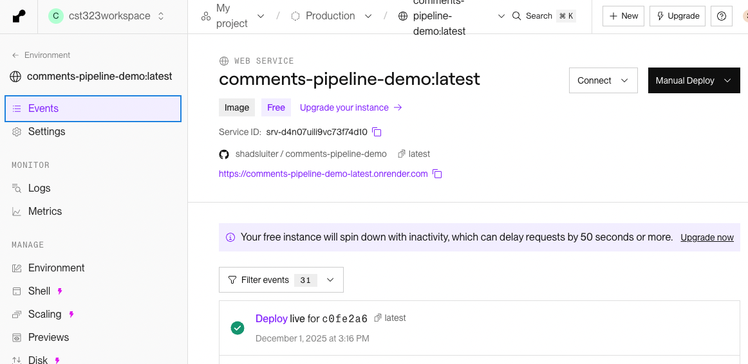

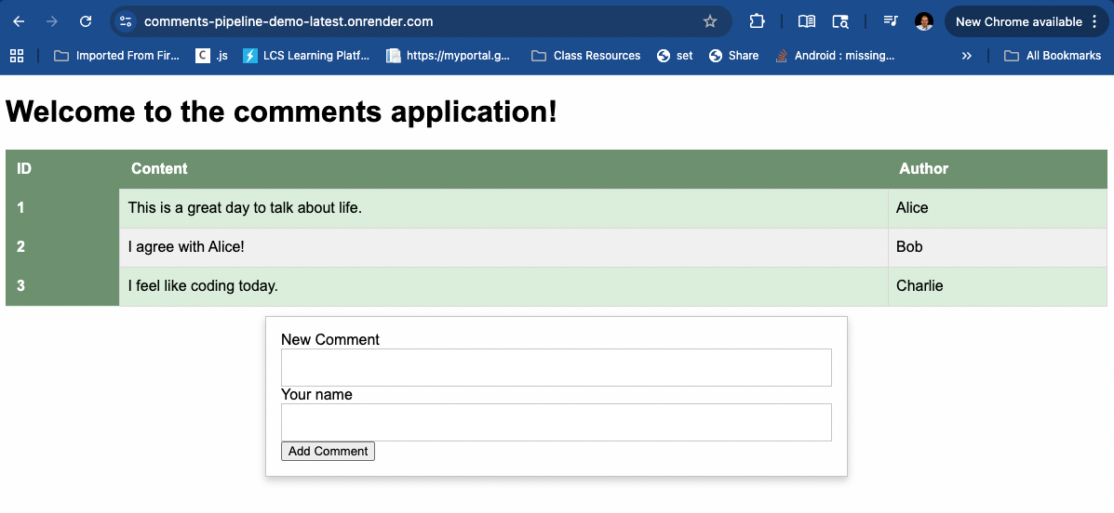
Figure 49 New update is seen live on the Render.com app

Screen Shot #5 – CSS changes on online application

- Take a screen shot of current status of the application.
- Paste the image into a Word document.
- Put a caption below the image explaining what is being demonstrated.

v3: add timestamps
The goal of this update is to modify the AppComment class to add a new property for the date and time the comment was created.

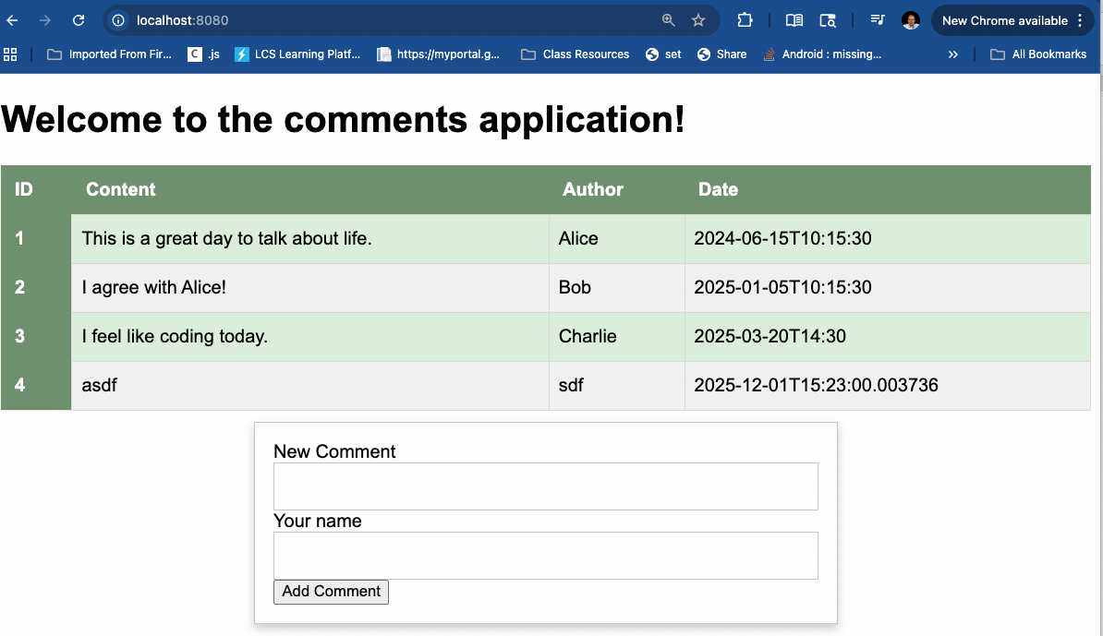
Figure 50 Time stamps are added to the comments app

Suggestions for code updates for v3
  - Add a new property for createdAt to the AppModel class.
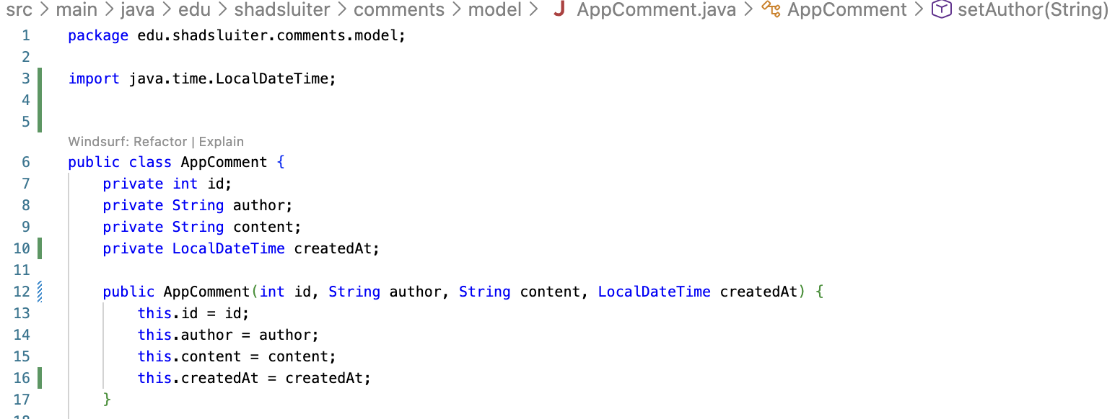

Use Java's modern time API:
import java.time.LocalDateTime;
Avoid java.util.Date and java.sql.Date.
- Add getters, setters and update the constructors.
- Update the CommentsDAO class to accommodate the new Date property.
- Update the index.html page to add a new column to the table.
- Run the appropriate Git add, commit and push commands.
- Verify that the GitHub action is completed correctly.
- Verify that the Render.com services publishes the new version.

Screen Shot #6 – Time Stamp Application Live

- Take a screen shot of current status of the application.
- Paste the image into a Word document.
- Put a caption below the image explaining what is being demonstrated.
- v4: add simple filtering/search
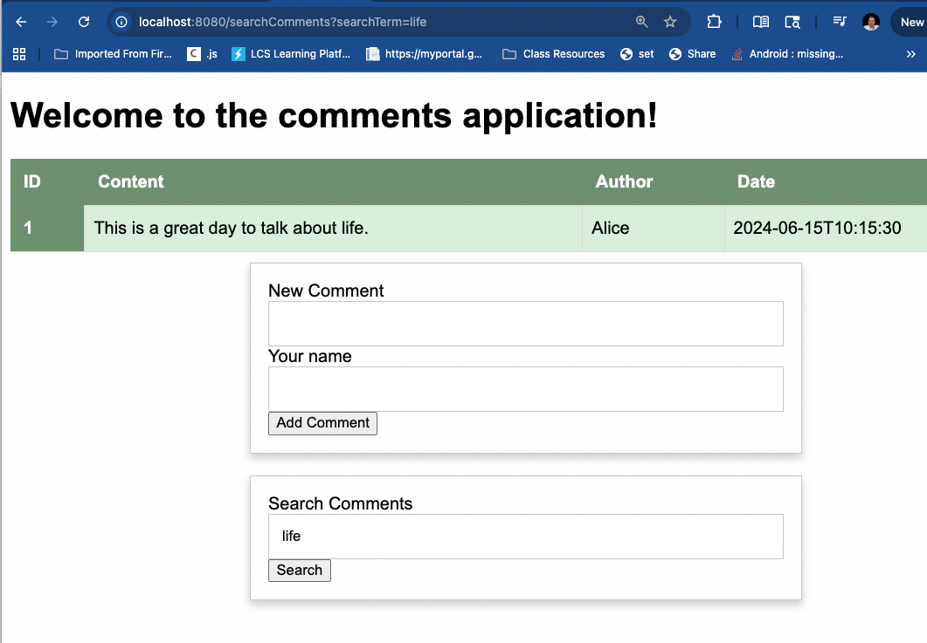
Figure 51 Search results for "life"

Process for Adding Search
- Modify index to add second form on index. The form should display a search comments input as shown.
- Modify the CommentsDAO to include a new method searchComments(String searchTerm). This method will return a filtered list of comments that contain the term.
- Modify the Controller to handle a request from the search form. The method should fetch the appropriate comments and display the index page again.
- Test the application until all errors are resolved.
- Use the Git add, commit, and push commands.
- Verify the GitHub action is completed.
- Verify the Render.com application is published.

Screen Shot #7 – Search Feature Online

- Take a screen shot of current status of the application.
- Paste the image into a Word document.
- Put a caption below the image explaining what is being demonstrated.

Collaborating with AI
As you level up from writing code to designing full deployment pipelines, AI becomes a partner in your growth. Instead of using AI only to fix errors or write snippets, you can use it to explore advanced ideas and learn what real engineering teams do every day. These prompts are designed to help you think bigger and ask better questions. Use AI as your collaborator, not your assistant, and let it help you discover what’s possible.
Choose one of these prompts to begin a conversation. Follow up with additional questions as you explore new knowledge.
In a Word document write a short summary of the ideas that AI helped you explore.

#1 Improving the CI/CD Pipeline
What are additions that would improve the GitHub Actions workflow shown in this activity to make it more production-ready? Explain what other steps in the process might be added such as testing, security scanning, tag versioning and more. In other words, tell me what I don’t know yet about routines that an enterprise application goes through on a CI CD pipeline.

#2 Company CI CD Examples
Provide real-world case studies of companies that deploy software dozens, hundreds, or even thousands of times per day. Explain how their engineering process makes this possible. Provide links to online stories or studies in addition to the summary you write for me. Include terms such as trunk-based development, canary releases, feature flags, automated testing, progressive delivery, error budgets and other terms that I probably am not aware of.

#3 Application Design
Explain how modern applications support frequent deployments using cloud-native architectures. Compare ideas such as monolithic deployments (like our Spring Boot app) with microservices and how this is more effective with automated deployments. Tell me about other strategies besides microservices.

Practice Quiz
Although not graded, these questions will help you prepare for upcoming assessments.

1. Which statement best explains why GitHub Actions is useful in a CI/CD pipeline?
A. It stores completed Docker images.
B. It automates workflows that run only when a user manually triggers them.
C. It automatically executes tasks (build, test, deploy) when events such as a push occur.
D. It replaces the need for Docker in cloud deployments.

2. A student’s GitHub Actions workflow fails with the error:
“Permission denied when pushing to ghcr.io.”
What is the most likely cause?**
A. The Dockerfile uses an incorrect base image.
B. The GHCR_PAT secret was not created or lacks the proper scope.
C. The Java version is misconfigured.
D. The workflow name does not match the repository name.

3. Why is a Dockerfile required for deploying the Spring Boot application to a cloud service like Render?
A. Render only accepts Java JARs compiled locally.
B. Docker ensures the app runs on the exact same environment everywhere.
C. Docker replaces the need for GitHub entirely.
D. Render uses Docker containers only when deploying to AWS.

4. In the GitHub Actions workflow, what is the primary purpose of the “checkout” step?
A. To install Docker on the runner.
B. To download the repository contents so the runner can build the project.
C. To validate YAML syntax.
D. To push code to the container registry.

5. Your workflow successfully builds a Docker image but Render does not update the live application. Which additional configuration is required?
A. Add a "deploy" job to GitHub that uploads JAR files manually.
B. Enable a Render Deploy Hook URL and store it as a repository secret.
C. Create a second Dockerfile named Renderfile.
D. Set Java version to 21 instead of 17.

6. Which best describes why CI/CD pipelines reduce the risk of deployment failures?
A. They slow down release cycles, giving developers more time to review code.
B. They enforce a single deployment per week.
C. They automate incremental steps such as testing and building, catching issues earlier.
D. They prevent developers from pushing code without manager approval.

7. Why is using a container registry (like GHCR) beneficial?
A. It eliminates the need to store source code in GitHub.
B. It provides a secure, versioned place to store container images used for deployment.
C. It automatically scales the application to multiple instances.
D. It replaces Docker Hub for all public repositories.

8. A team wants to deploy code hundreds of times per day. Which CI/CD practice most enables this?
A. Large, infrequent code merges
B. Manual approvals for each deployment
C. Trunk-based development with heavy automation
D. Rewriting the application in a different language

9. What is the biggest drawback of using a monolithic architecture when practicing rapid deployments?
A. It has too many small services to manage.
B. One small change requires rebuilding and redeploying the entire application.
C. It cannot run inside a Docker container.
D. It requires older versions of Java.

10. Which step in the workflow is most responsible for ensuring repeatability across environments?
A. The .gitignore file
B. The Dockerfile
C. The README documentation
D. The Render dashboard configuration

Answer Explanations

1. (C) GitHub Actions automatically executes tasks (build, test, deploy) when events such as a push occur.
GitHub Actions is event-driven: when you push, merge, or create a pull request, it can automatically run workflows like building or deploying your app—key behavior in CI/CD.

2. (B) The GHCR_PAT secret was not created or lacks the proper scope.
Pushing to GHCR requires authentication. If the personal access token is missing or not configured with write:packages, Docker cannot push the image, resulting in permission errors.

3. (B) Docker ensures the app runs on the exact same environment everywhere.
Containers encapsulate the runtime environment, tools, OS, dependencies, and configuration. This eliminates "works on my machine" issues and guarantees consistent behavior across local, CI, and cloud environments.

4. (B) To download the repository contents so the runner can build the project.
The GitHub Actions runner starts with a clean machine. The checkout action pulls your code from GitHub so steps like Maven build and Docker build can access the files.

5. (B) Enable a Render Deploy Hook URL and store it as a repository secret.
Render does not automatically redeploy when a Docker image changes. A Deploy Hook acts like a webhook: GitHub pings Render when the workflow finishes, triggering a new deployment.

6. (C) They automate incremental steps such as testing and building, catching issues earlier.
CI/CD reduces risk through automation. Each commit is validated immediately, identifying regressions quickly and preventing large batches of untested code from shipping.

7. (B) It provides a secure, versioned place to store container images used for deployment.
A container registry is like a database for Docker images. It manages versions, permissions, and distribution so cloud services can pull your image reliably.

8. (C) Trunk-based development with heavy automation.
High-frequency deployers (Google, Meta, Amazon) avoid long-lived branches. They rely on rapid merges into main, automated tests, and automated deploy pipelines to support hundreds of releases per day.

9. (B) One small change requires rebuilding and redeploying the entire application.
Monoliths bundle everything into a single deployable artifact. A small fix or feature requires redeploying the whole system, slowing down release cycles compared to microservices.

10. (B) The Dockerfile.
The Dockerfile defines exactly how the application is built, configured, and run. It ensures that whether you're deploying locally, on GitHub Actions, or on Render, the environment is always identical.

Deliverables

1. Screenshots
Insert all required screenshots into one Word document, in the order listed below.
Each screenshot must include:
- A short caption describing what is being demonstrated
- Clear visibility of the key information (logs, UI changes, GitHub Actions results, etc.)

Required Screenshots
# | Screenshot Description | When It Happens
1 | Local Application Running – the starter comments app functioning on localhost (before any pipeline work). | After Step 2
2 | GitHub Repository Populated – confirmation that all project files appear in GitHub after initialization and the first push. | After Step 5
3 | Successful GitHub Actions Workflow – show the green checkmark and workflow steps expanding under buildandpush. | After Step 9
4 | Live Deployment on Render.com – the application running on the public Render URL (v0 baseline). | After initial Render deployment
5 | v1 Table Layout Version Live – the app displayed in table form after the first UI change is deployed. | After v1 push and deploy
6 | v2 CSS Styling Version Live – after adding styling, show the updated presentation online. | After v2 push and deploy
7 | v3 Timestamp Version Live – show the new timestamp column functioning online. | After v3 push and deploy
8 | v4 Search Feature Online – demonstrate a search query working with filtered results. | After v4 push and deploy

2. AI Collaboration Write-Up
In a separate section of the Word document (near the end), include:

The AI Prompt You Selected
Choose one of the following prompts and paste it into your write-up:
- Improving the CI/CD Pipeline
- Company CI/CD Examples
- Application Design

3. Completed Java Project in GitHub
Link to your GitHub project.
Provide permissions for your instructor to read the repo.
Your GitHub repository must contain:
- The working Spring Boot application
- Dockerfile
- GitHub Actions workflow
- All v1–v4 updates (table layout, styling, timestamps, search)
- A functioning automated pipeline that pushes images to GHCR
- Automatic deployment to Render via Deploy Hook

Rubric – Automated CI/CD Pipeline Activity
Category | 100% – Exemplary | 90% – Strong | 80% – Adequate | 70% – Developing | 60% – Minimal | 0 – Missing
Screenshots & Documentation | All required screenshots (≤10) included, clear, correctly ordered, and fully demonstrate pipeline stages and all v1–v4 updates. | One screenshot missing OR minor clarity issues. | Two required screenshots missing or unclear. | Several screenshots missing or poorly labeled. | Screenshots present but do not demonstrate required stages. | No screenshots submitted.
Pipeline Functionality | GitHub Actions builds successfully, pushes to GHCR, and Render auto-deploys all versions (v0–v4). | Pipeline works but with minor inconsistencies (e.g., occasional rebuild errors). | Pipeline builds but deployment requires manual intervention. | Pipeline partially works but major steps fail. | Pipeline set up incorrectly; mostly nonfunctional. | Pipeline missing entirely.
Application Updates (v1–v4) | All four updates implemented correctly and deployed live with visible differences. | Three updates implemented correctly. | Two updates implemented. | One update implemented. | Attempt made but none functional. | No updates committed.
AI Collaboration & Reflection | Meaningful reflection demonstrating insight; prompt included; clear evidence of learning beyond task instructions. | Good reflection; minor depth issues. | Reflection present but superficial. | Very brief reflection with little understanding. | Reflection submitted but missing required elements. | No AI section submitted.

